To use ANSYS Fluent in your house, please use VDI (See below Link)

https://engineering.uiowa.edu/etc/help-desk-computer-services/information/virtual-windows-desktop-vdi

Verification of Laminar and Validation of Turbulent Pipe Flows

ME:5160 Intermediate Mechanics of Fluids

CFD LAB 1

(ANSYS 2025 R2; Last Updated: August 4, 2026)

By Timur Dogan, Michael Conger, Dong-Hwan Kim, Sung-Tek Park,
Christian Milano, Maysam Mousaviraad, Tao Xing and Fred Stern

IIHR-Hydroscience & Engineering
The University of Iowa
C. Maxwell Stanley Hydraulics Laboratory
Iowa City, IA 52242-1585

- Purpose
The Purpose of CFD Lab 1 is to simulate steady laminar and turbulent pipe flow following the “CFD Process” by an interactive step-by-step approach. Students will have hands-on experiences using ANSYS to compute axial velocity profile, centerline velocity, centerline pressure, and friction factor. Students will conduct verification studies for friction factor and axial velocity profile of laminar pipe flows, including iterative error and grid uncertainties and effect of refinement ratio on verification. Students will validate turbulent pipe flow simulation using EFD data, analyze the differences between laminar and turbulent flows, and present results in CFD Lab report.

Geometry
Physics
Mesh/Grid
Solution
Results
Pipe (ANSYS Design Modeler)
Structure (ANSYS Mesh)
Non-uniform (ANSYS Mesh)
Uniform (ANSYS Mesh)
General (ANSYS Fluent - Setup)
Model (ANSYS Fluent - Setup)
Boundary Conditions (ANSYS Fluent -Setup)
Reference Values (ANSYS Fluent - Setup)
Laminar
Turbulent
Solution Methods (ANSYS Fluent - Solution)
Monitors (ANSYS Fluent - Solution)
Solution Initialization (ANSYS Fluent -Solution)
Plots (ANSYS Fluent- Results)
Graphics (ANSYS Fluent- Results)

Flow Chart for “CFD Process” for pipe flow
- Simulation Design

In CFD Lab 1, simulation will be conducted for laminar and turbulent pipe flows. Reynolds number is 655 for laminar flow and 111,569 for turbulent pipe flow, respectively. The schematic of the problem and the parameters for the simulation are shown below.

Table 1 - Main Particulars
Parameter | Unit | Value
Radius of Pipe | m | 0.02619
Diameter of Pipe | m | 0.05238
Length of the Pipe | m | 7.62

Outlet
Inlet
Symmetry Axis
Pipe Wall

Non-uniform Grid
Uniform Grid
Velocity Profile

Since the flow is axisymmetric we only need to solve the flow in a single plane from the centerline to the pipe wall. Boundary conditions need to be specified include inlet, outlet, wall, and axis, as will be described details later. Uniform flow was specified at inlet, the flow will reach the fully developed regions after a certain distance downstream. No-slip boundary condition will be used on the wall and constant pressure for outlet. Symmetric boundary condition will be applied on the pipe axis. Uniform grids will be used for the laminar flow whereas non-uniform grid will be used for the turbulent flow.

Table 2 - Grids
Grid/Mesh | Grid/Mesh Type | # of Divisions
Grid/Mesh | Grid/Mesh Type | X | R
8 | Uniform | 453 | 45
7 | Uniform | 319 | 32
6 | Uniform | 226 | 23
4 | Uniform | 113 | 11
3 | Uniform | 80 | 8
2 | Uniform | 56 | 6
0 | Uniform | 28 | 3
T | Non-uniform | 564 | 15

Experimental, analytical results, and simulation results will be compared. Additionally, detailed verification and validation study will be conducted. All the studies are detailed in the Table 3. In this manual, detailed instructions are given for the laminar flow simulation and turbulent flow simulation using uniform grid 8 and non-uniform grid respectively. For the rest of the simulations, the grid and simulation setups have been provided with workbench uploaded on the class website:

(1) go to “https://stern.lab.uiowa.edu/me51600001-intermediate-mechanics-fluids”
(2) go to “CFD Labs” tab
(3) go to “CFD Lab1: Pipe Flow” tab
(4) download “CFD Lab1 Workbench” (wb.wbpz)

Please refer to the exercise at the end of the manual to determine the data and figures that need to be saved before you analyze (postprocess) any result. Even though the manual shows every possible step for analyzing the data at Section 7 & 8, only certain subsections (e.g. 7.3, 7.4, 7.7) will be required for each exercise.

Table 3 - Simulation Matrix
Study | Grid | Model
V&V of friction factor and axial velocity profile | 2,3,4 | Laminar
V&V of friction factor | 6,7,8 | Laminar
V&V of friction factor | 0,2,4 | Laminar
V&V of friction factor | 4,6,8 | Laminar
Axial velocity, centerline velocity | 8 | Laminar
Axial velocity, centerline pressure, centerline velocity | T | Turbulent

All analytical data (AFD) and experimental data (EFD) needed for the comparison with laminar and turbulent flow CFD results, respectively, can be downloaded from the class website again:

(1) go to “https://stern.lab.uiowa.edu/me51600001-intermediate-mechanics-fluids”
(2) Click RMB on “axialvelocityAFD-laminar-pipe.xy” and select “Save link as…”
(3) Click RMB on “axialvelocityEFD-turbulent-pipe.xy” and select “Save link as…”
(4) Click RMB on “pressure-EFD-turbulent-pipe.xy” and select “Save link as…”
- Open ANSYS Workbench Template

  - Start > All Programs > ANSYS 2025 R2 > Workbench 2025 R2
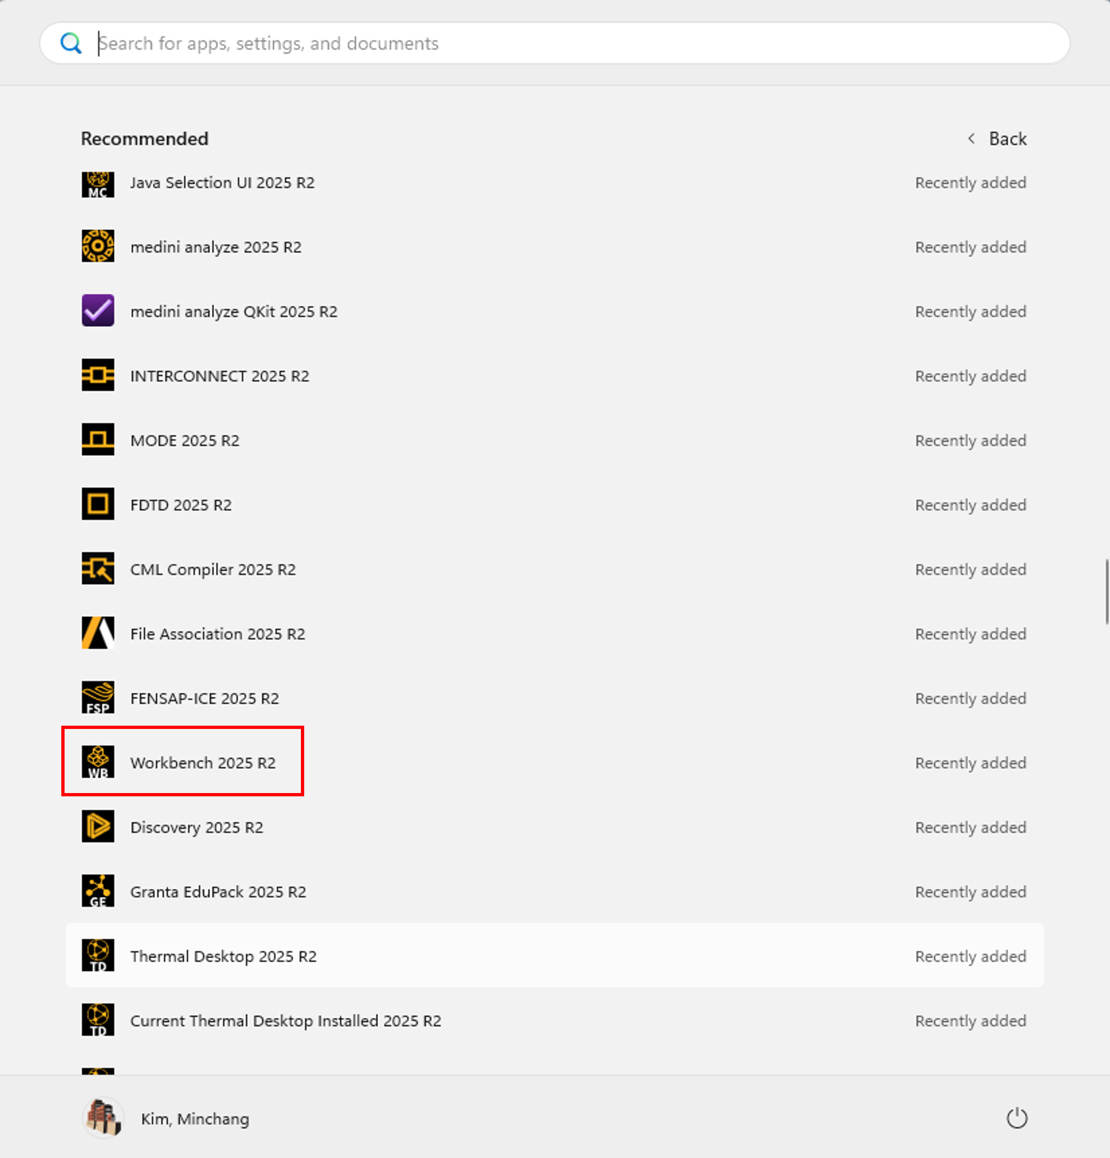

  - You can ignore all the pop-ups by clicking “Cancel” if you see any.

  - Toolbox > Component Systems. Click and Drag & Drop [Geometry], [Mesh] and [Fluent] components to Project Schematic as per below.
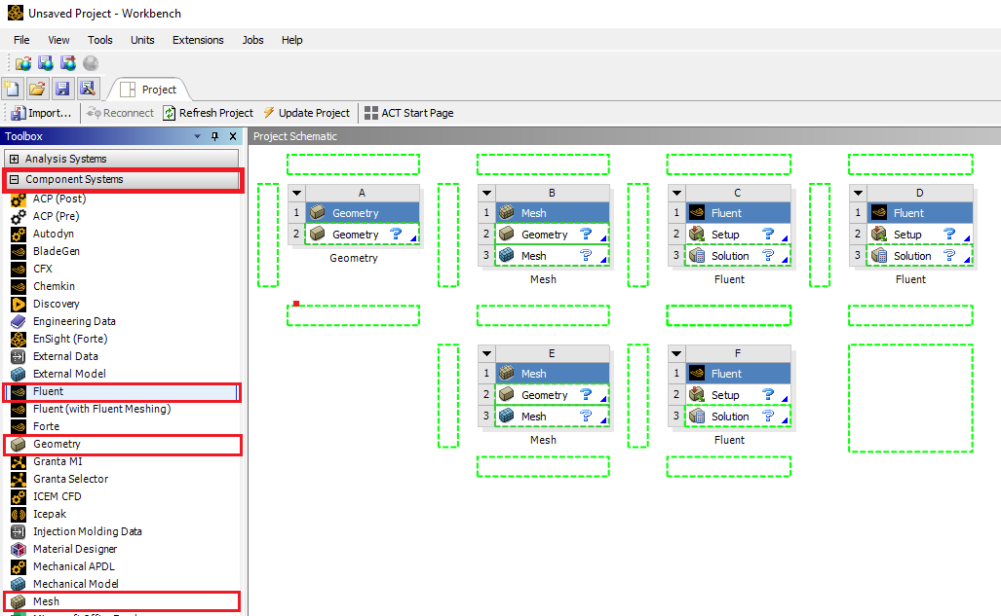
  - Click on the drop down arrow and select Rename. Change the names as per below to avoid any confusion during the work.
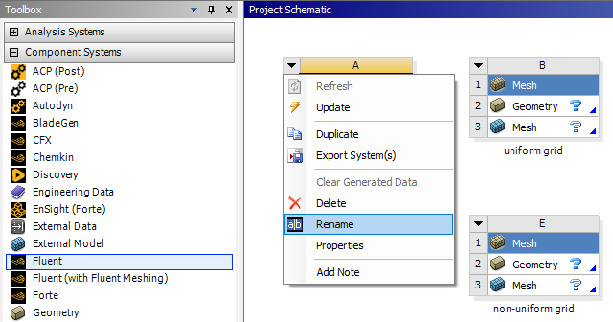
Result:
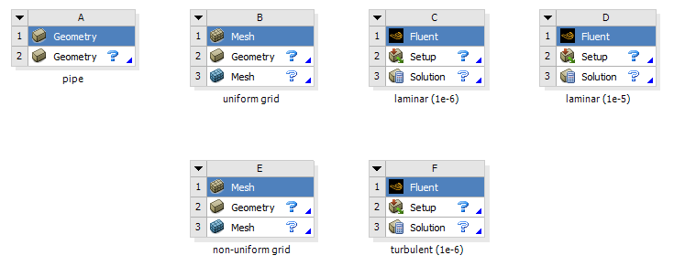

  - Create connections between component as per below. To make connections, click and drag the [Geometry ?] box to the [Mesh ?] box, and the [Mesh ?] box to the [Setup ?] box as per below.
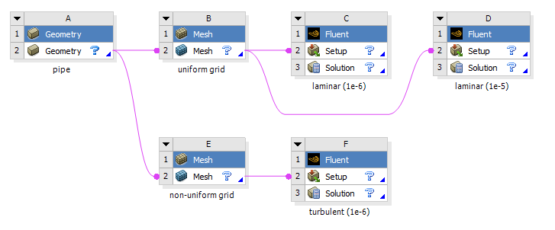
  - File > Save As. Save the workbench file to H drive (i.e. home.iowa.uiowa.edu drive). The H drive is shared between the computers in engineering labs.

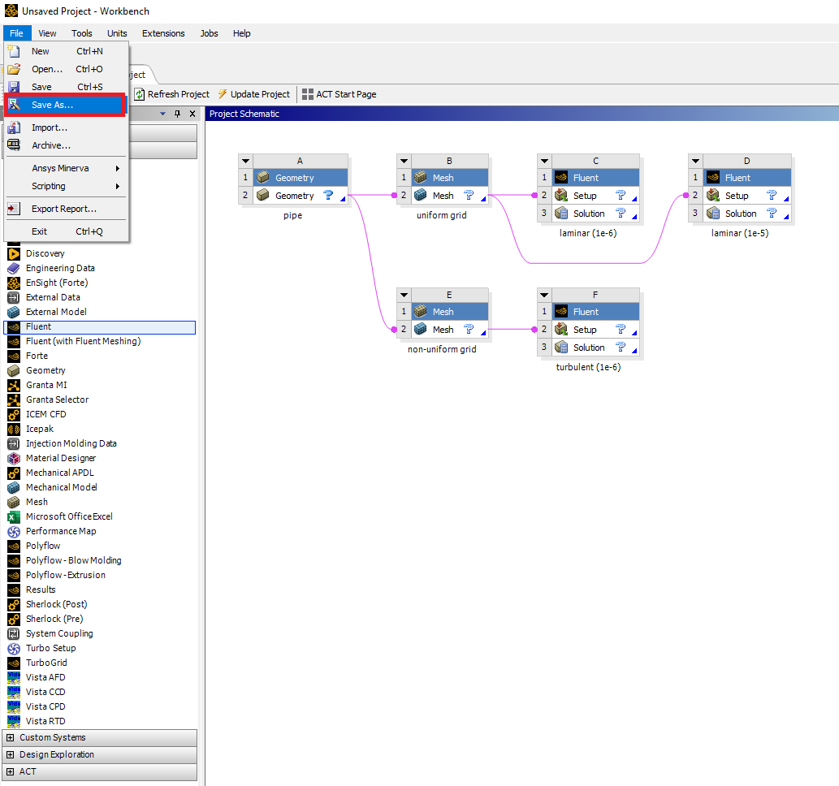

- Geometry Creation

  - Right click Geometry and select New DesignModelerGeometry…. (Since all the geometries are linked together, only one geometry creation is required)
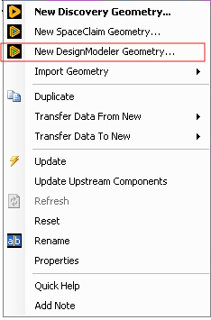

  - Make sure that Unit is set to Meter (default value).
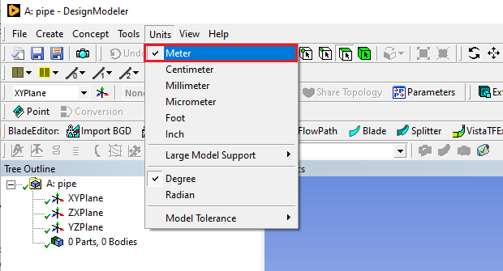

  - Select the XYPlane under the Tree Outline and click New Sketch button.
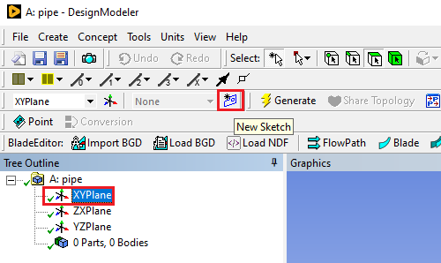
  - Right click Sketch1 and select Look at.
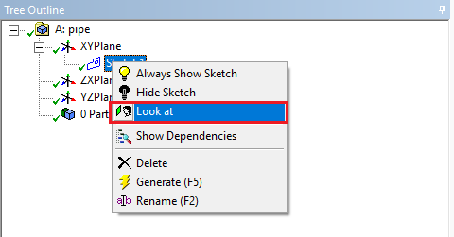

  - Enable the auto constraints option to pick the exact point as below. Select Sketching > Constraints > Auto Constraints > make sure Cursor is selected.
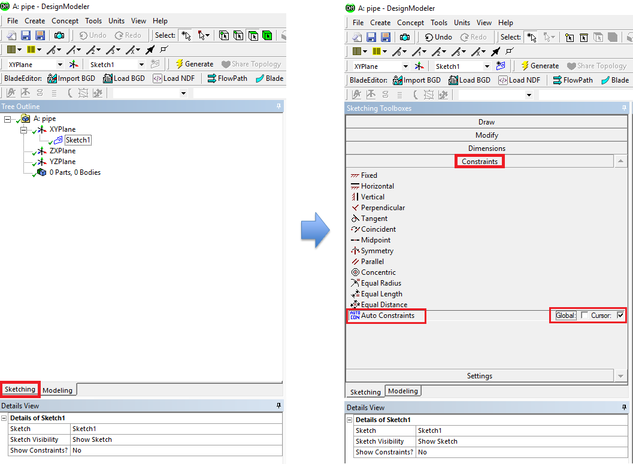

  - Select Sketching > Draw > Rectangle. Create a rectangle geometry as per below. The cursor will show “P” when it is on the origin point.
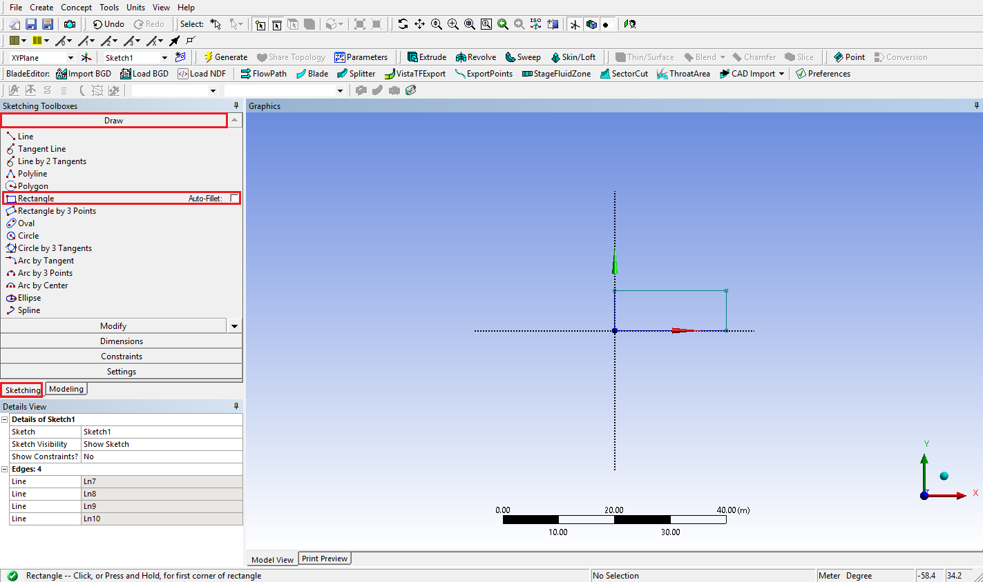

  - Select Sketching > Dimensions > General. Click on top edge then click anywhere else. Repeat the same thing for one of the vertical edges. You should have a similar figure as per below.
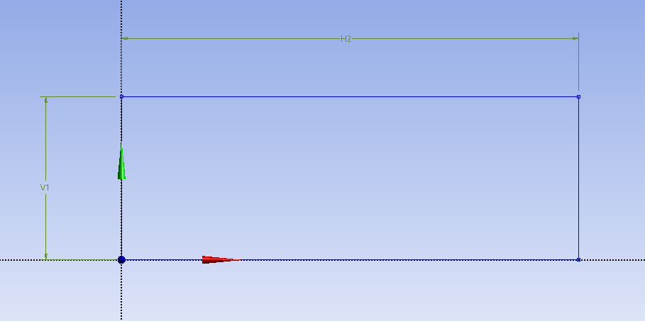

  - Click on H2 under Details View and change it to 7.62m. Click on V1 and change it to 0.02619m. Always omit units (“m” for this time) when you put in values.
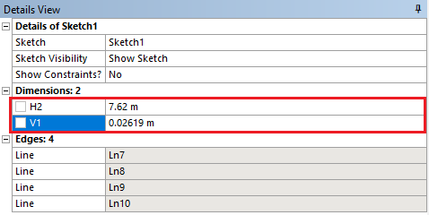
  - Concept > Surfaces From Sketches and select Sketch1 from the Tree Outline and hit Apply on Base Objects under Details view.
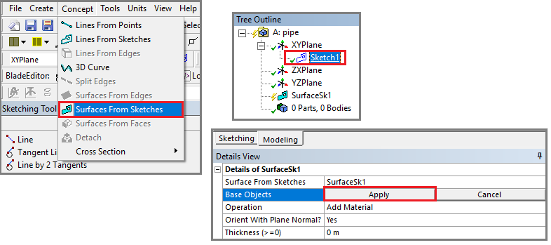
  - Click Generate. This will create a surface.
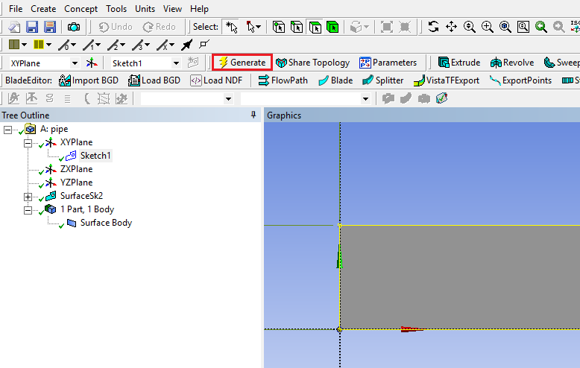
  - File > Save Project. Save project and close window.

  - If you see the lightning sign next to Geometry in the workbench then right click on the Geometry and click Update as shown below. If you don’t see the check mark after the update, then you may have made a mistake when you were creating the geometry.
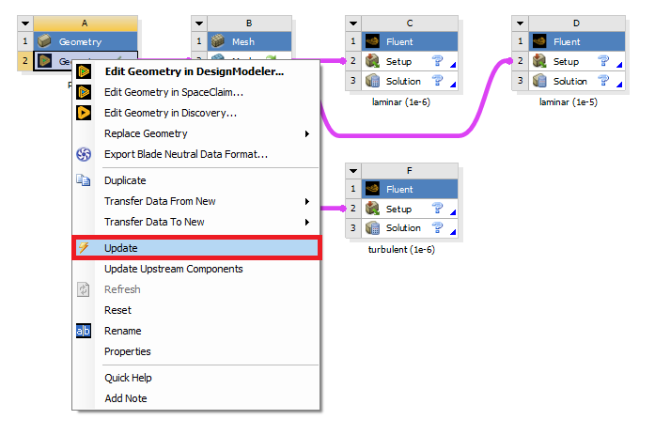

- Mesh Generation

  - Right click on Mesh and select Edit.
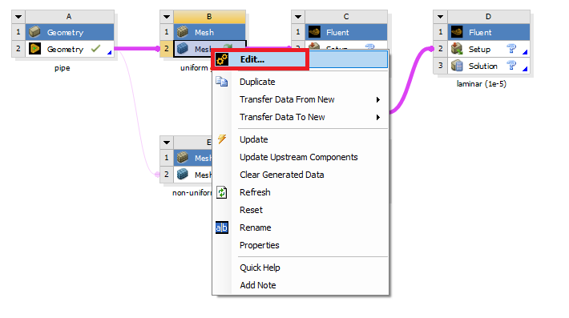

  - Right click on Mesh then select Insert > Face Meshing.
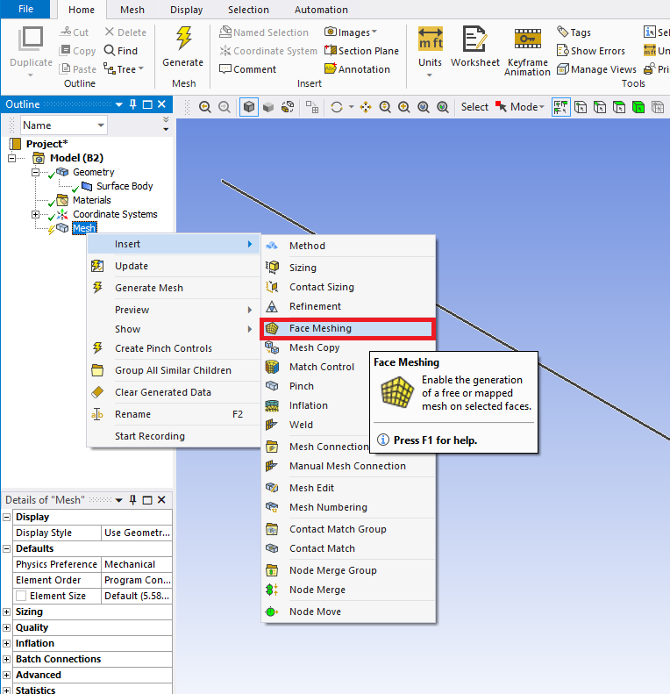
  - Select the pipe geometry by clicking anywhere on the pipe surface, then click the yellow box that says “No Selection” and click Apply. (From now on, rotate the view to xy-plane by clicking z-axis of 3D axis located at right bottom of the screen. You can drag and drop with right mouse button to zoom in. You can press F7 to restore the view.)
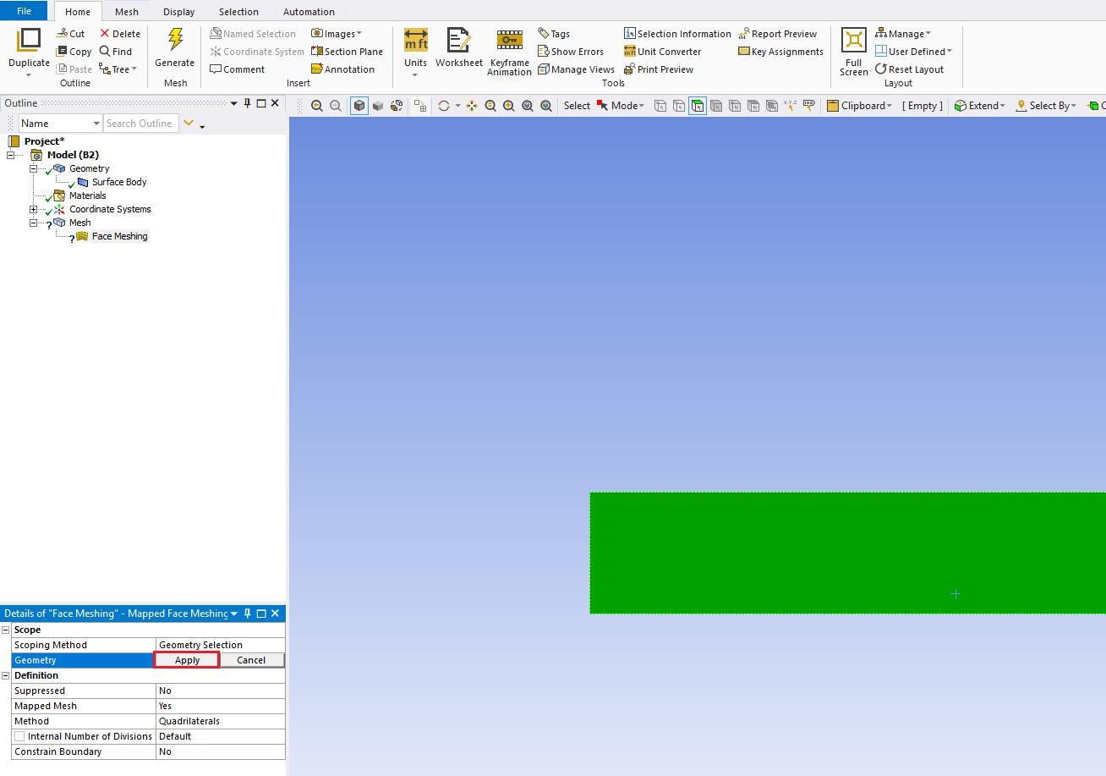

  - Click on the Edge Button. This will allow you to select edges of your geometry.
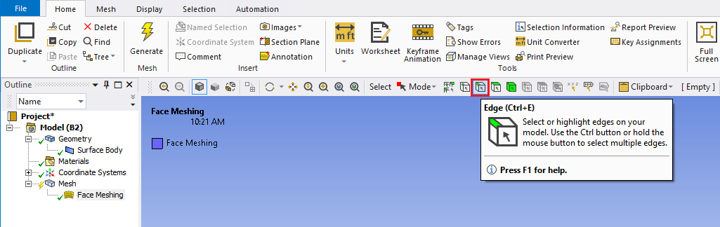
  - Right click on Mesh then select Insert > Sizing.
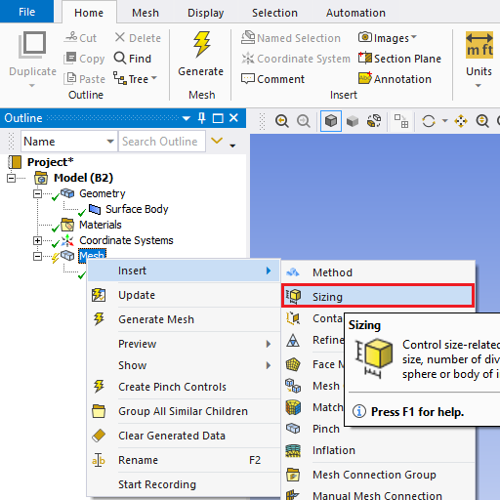
  - Hold Ctrl and select the top and bottom edge then click Apply in the Details box for Geometry on the right. Specify details of sizing as per below depending on the case.

Laminar
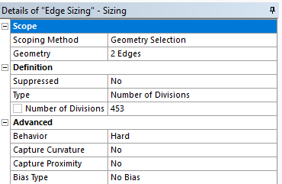
Turbulent
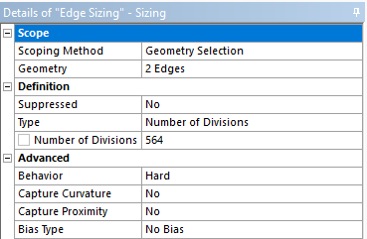
  - Repeat step 5.5. Select the left and right edge and click Apply for uniform grid flow and change sizing parameters as per below. Change the sizing parameters separately for non-uniform grid as per below. Make sure to select edges individually when changing sizing parameters for non-uniform grid.
Uniform Grid 8
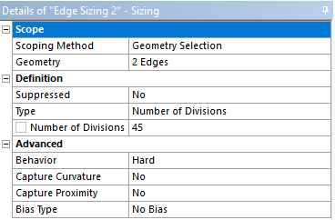

Non-uniform Grid Left Edge
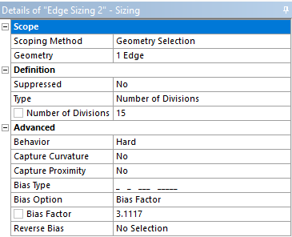
Non-uniform Grid Right Edge
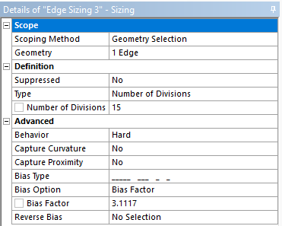
  - Click on Generate Mesh button and click Mesh under Outline to show mesh.
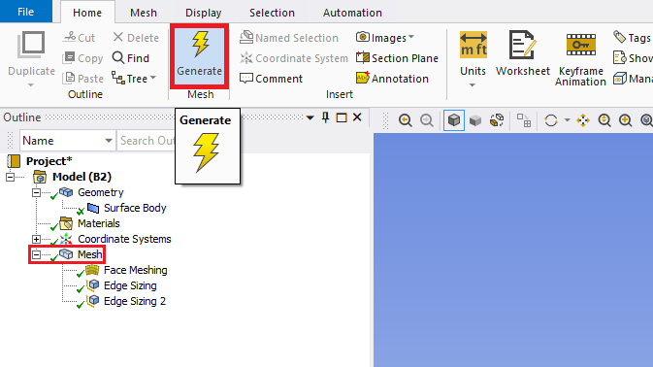
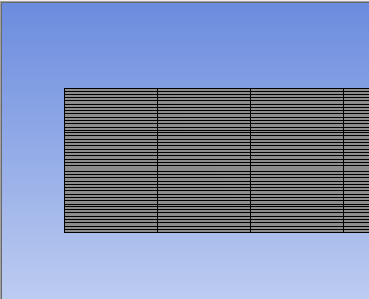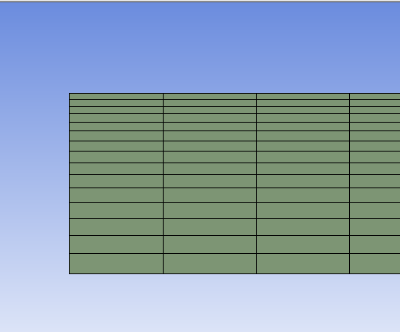
Non-uniform Grid
Uniform Grid 8

  - Change the edge names by clicking on the edge, clicking RMB and selecting Create Named Selection. Name left, right, bottom and top edges as inlet, outlet, axis and wall respectively. At this stage, your outline should look same as the figure below.

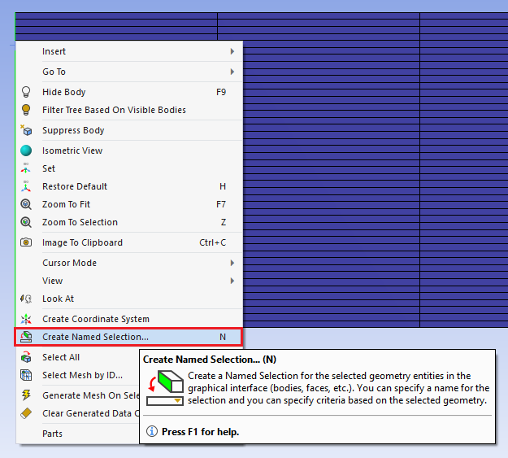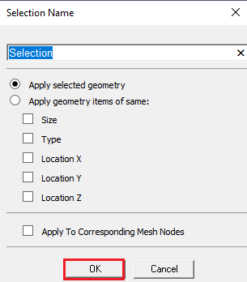
Uniform Grid 8
Non-uniform Grid
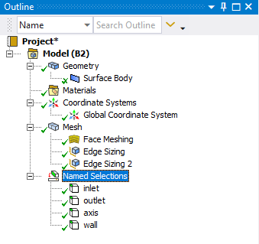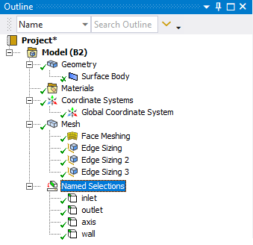

  - File > Save Project. Save the project and close the window. Update mesh by clicking RMB on Mesh and clicking Update on Workbench.

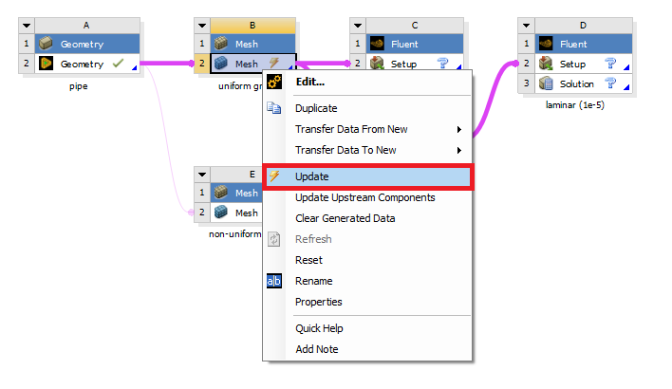

- Solve

  - Right click Setup and select Edit.
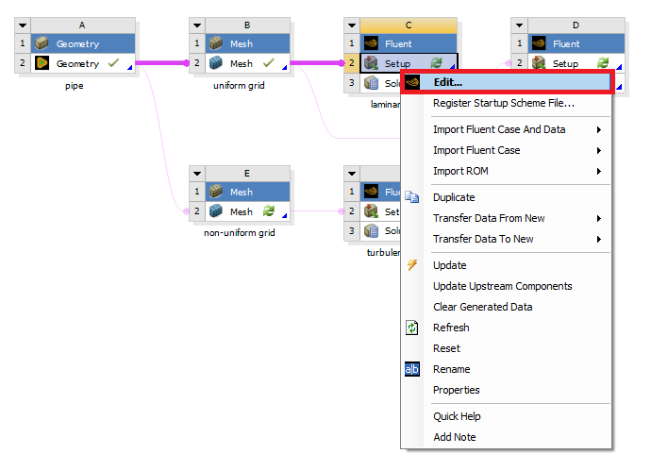

  - Under options check Double Precision and click START.
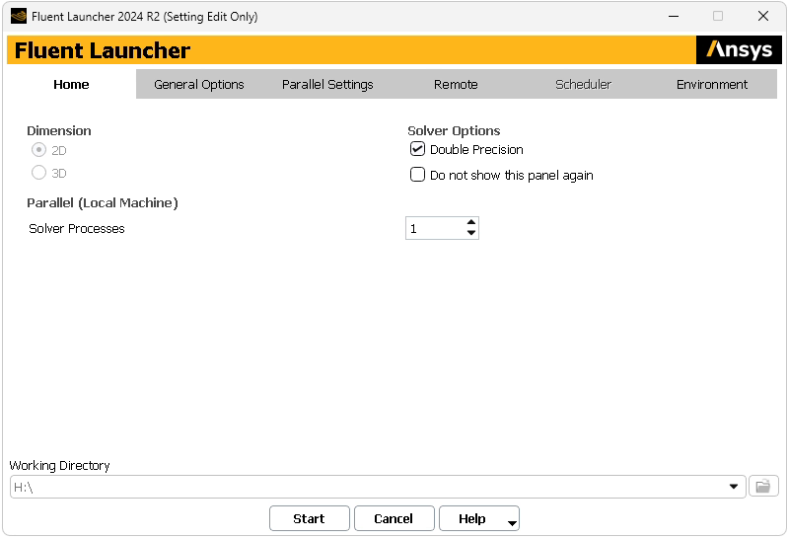

  - Fold the upper tool box by clicking the button inside the red box to avoid any confusion. For this section 6, the “tree outline” on the left side bar will be used only.
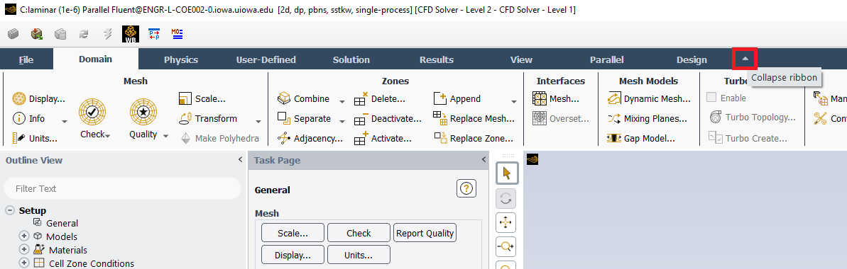

  - Tree > Setup > General > Check. You may ignore the warning messages if pop up. (Note: If you get an error message you may have made a mistake while creating your mesh)
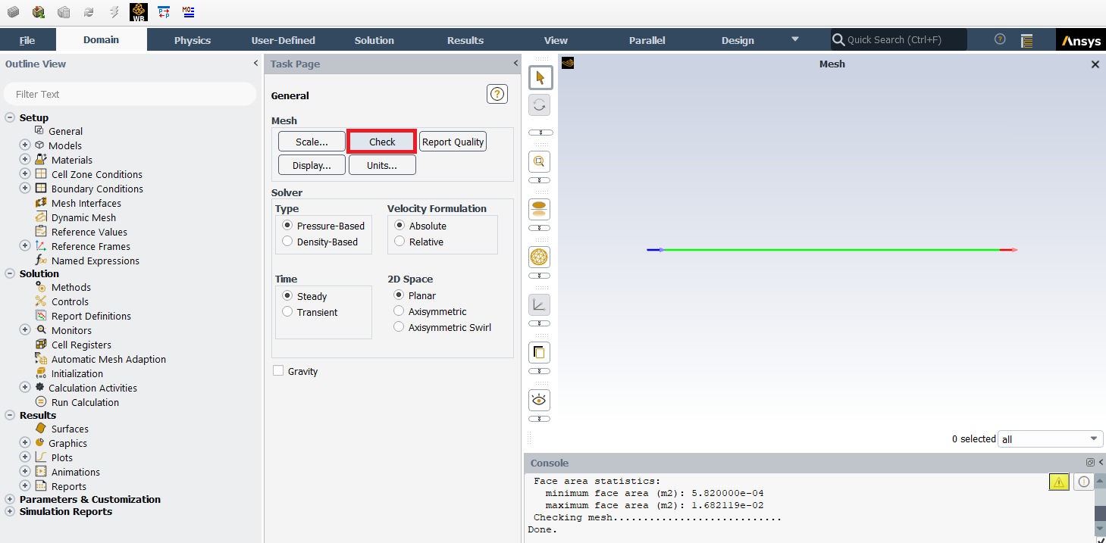

  - Setup > General > Solver. Choose an option shown below.
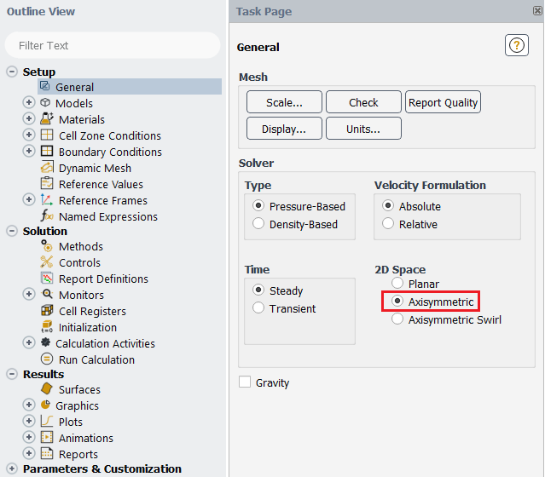

Axis Boundary Condition
Model | Laminar |  |  | Turbulent
Variable | u  [m/s] | v  [m/s] | P  [Pa] | u  [m/s] | v  [m/s] | P  [Pa] | k  [m²/s²] | e  [m²/s³]
Magnitude | - | 0 | - | - | 0 | - | - | -
Zero Gradient | Y | N | Y | Y | N | Y | Y | Y
(above table explains the adaption of axisymmetric condition for the “axis” boundary condition)

  - Tree > Setup > Models >Viscous (double click). Select parameters as per below and click OK(Apply).
Laminar flow
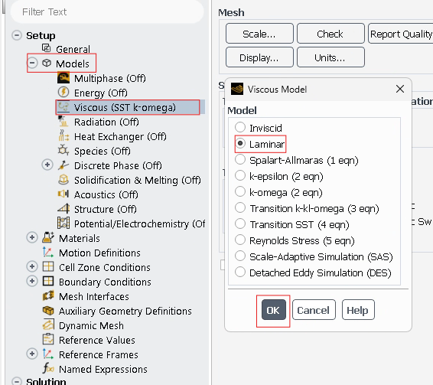
Turbulent flow
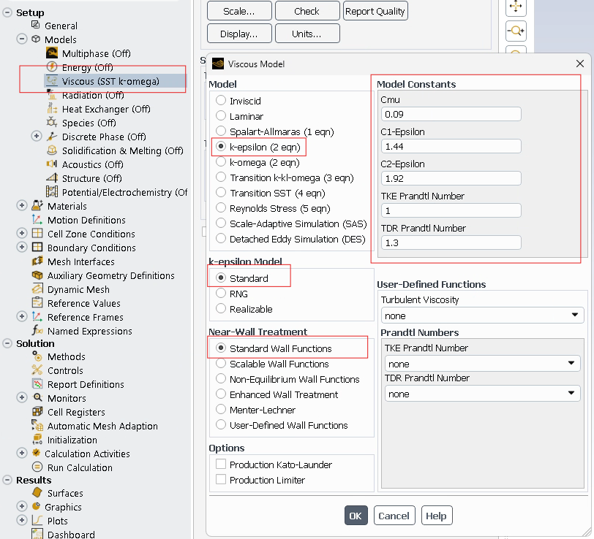
  - Tree > Setup > Materials > Fluid > air (double click). Change the Density and Viscosity as per below and click Change/Create. Close the dialog box when finished.
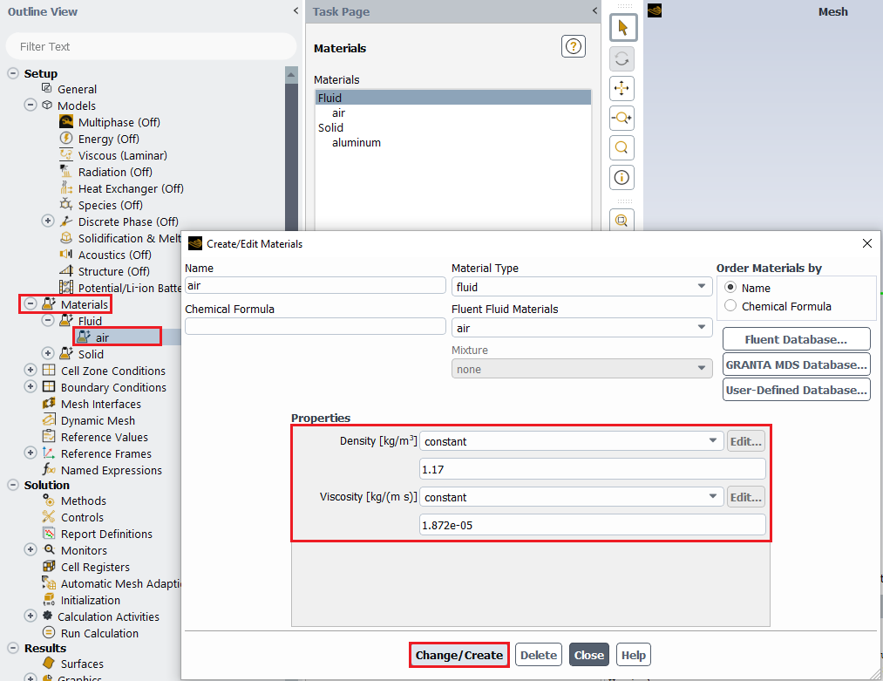
  - Tree > Setup > Cell Zone Conditions(Double click) > Zone > surface_body. Change type to fluid, make sure air is selected and click Apply.
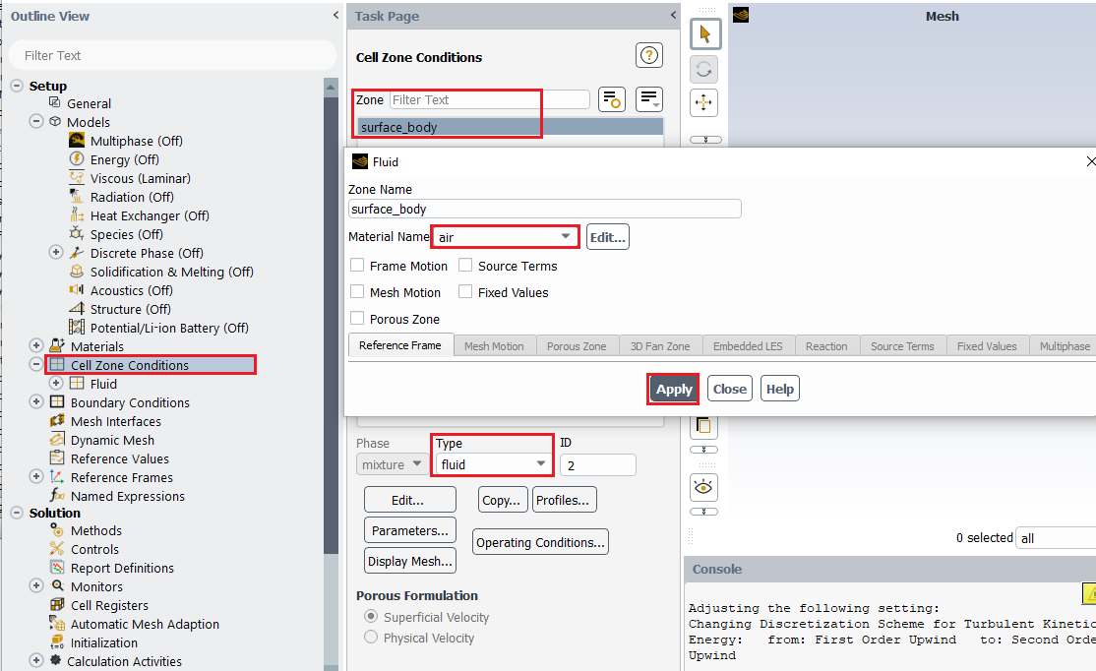
  - Tree > Setup > Boundary Conditions > inlet (double click). Change parameters as per below and click Apply.
Laminar flow
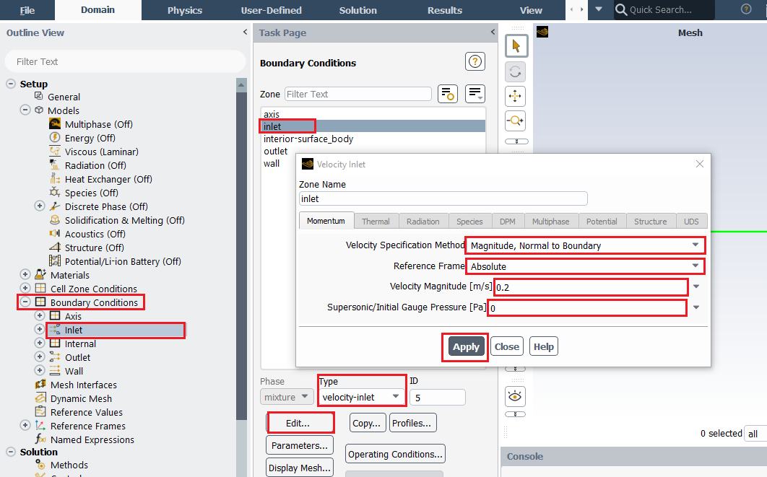
Turbulent flow
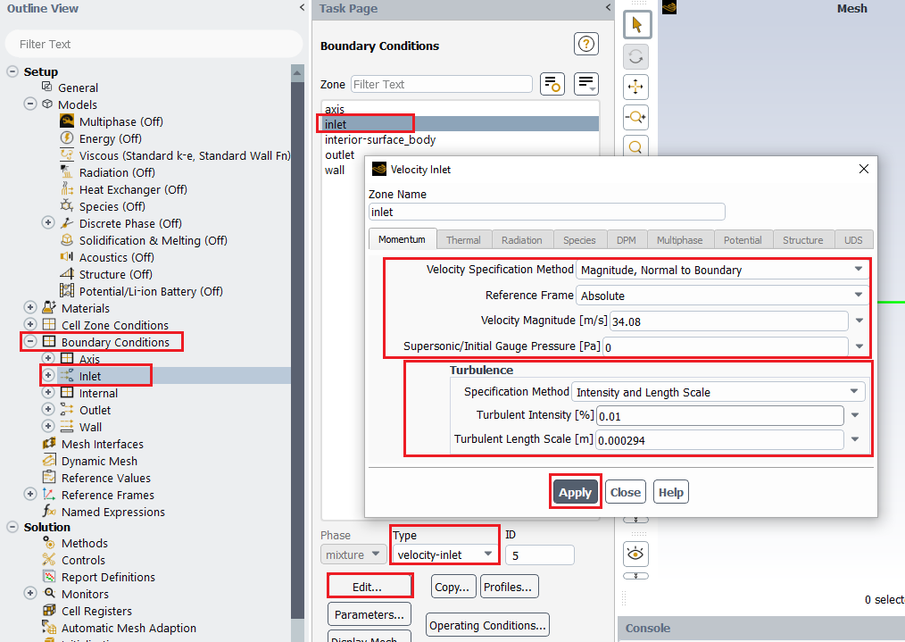
Inlet Boundary Condition
Model | Laminar |  |  | Turbulent
Variable | u [m/s] | v [m/s] | P [Pa] | u [m/s] | v [m/s] | P [Pa] | Intensity | Length Scale
Magnitude | 0.2 | 0 | - | 34.08 | 0 | - | 0.01 | 0.000294
Zero Gradient | N | N | Y | N | N | Y | N | N
  - Tree > Setup > Boundary Conditions > outlet (double click) or click Edit…. Change parameters as per below and click Apply.
Laminar flow
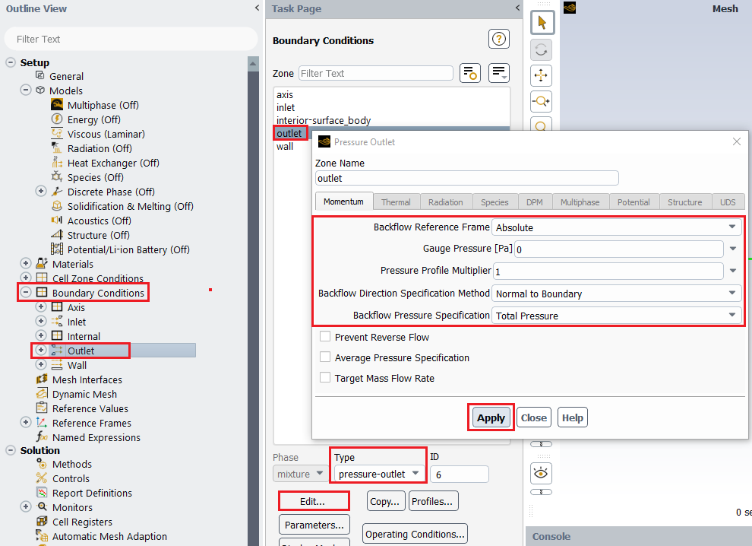
Turbulent flow
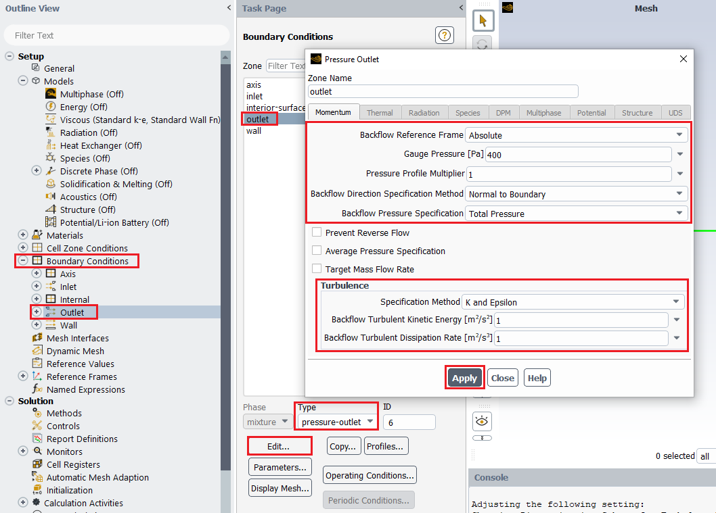

Outlet Boundary Condition
Model | Laminar |  |  | Turbulent
Variable | u [m/s] | v [m/s] | P [Pa] | u [m/s] | v [m/s] | P [Pa] | k [m²/s²] | e [m²/s³]
Magnitude | - | - | 0 | - | - | 400 | 1 | 1
Zero Gradient | Y | Y | N | Y | Y | N | Y | Y
  - Tree > Setup > Boundary Conditions > wall (double Click) Change parameters as per below and click Apply. No need to change for laminar cases.
Laminar flow
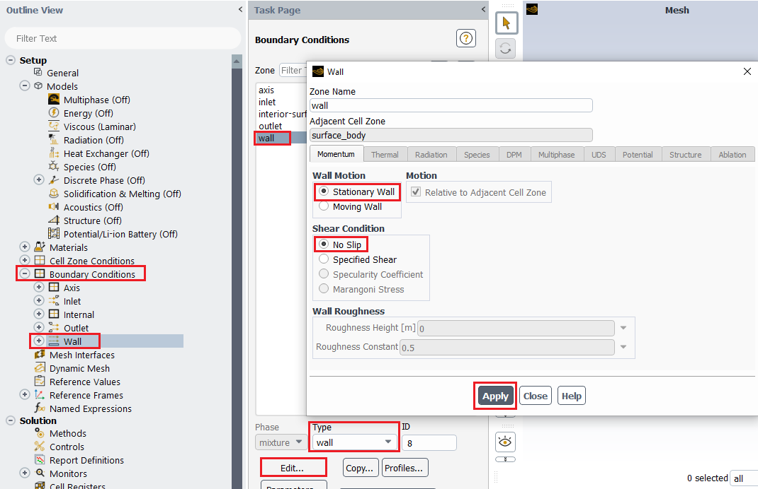
Turbulent flow
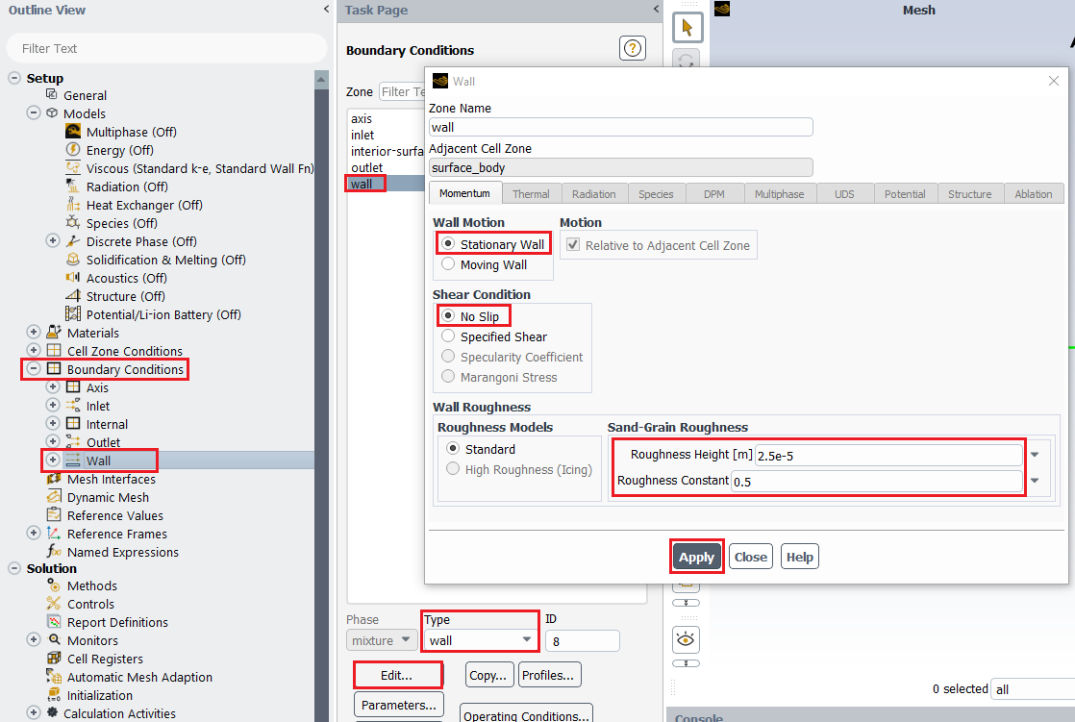
Wall Boundary Condition
Model | Laminar |  |  | Turbulent
Variable | u  [m/s] | v  [m/s] | P  [Pa] | u  [m/s] | v  [m/s] | P  [Pa] | k  [m²/s²] | e  [m²/s³] | Roughness
Magnitude | 0 | 0 | - | 0 | 0 | - | - | - | 2.50E-05
Zero Gradient | N | N | Y | N | N | Y | N | N | -
  - Tree > Setup > Boundary Conditions > Operating Condition…. Change parameters as per below and click OK.
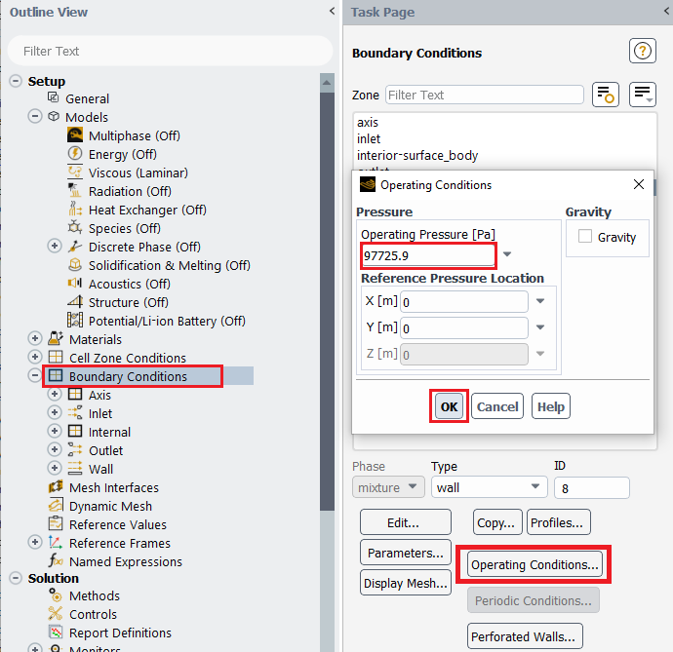

  - Tree > Setup > Reference Values. Change parameters as per below.
Laminar flow
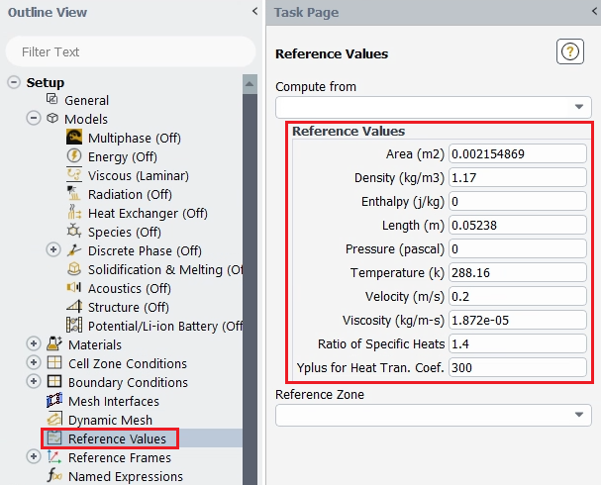

Turbulent flow
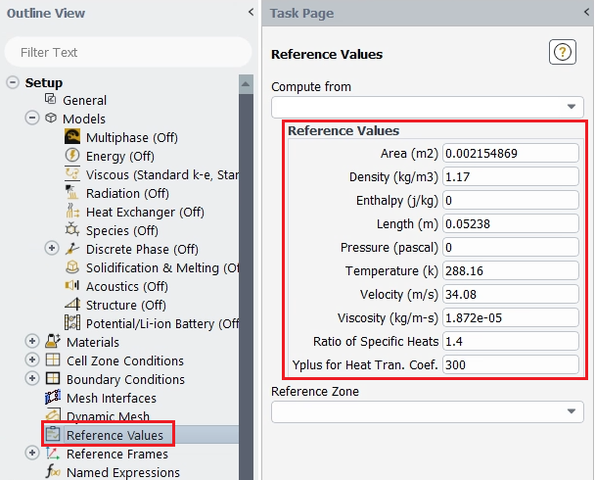

  - Tree > Solution > Methods. Change parameters as per below.
Laminar flow
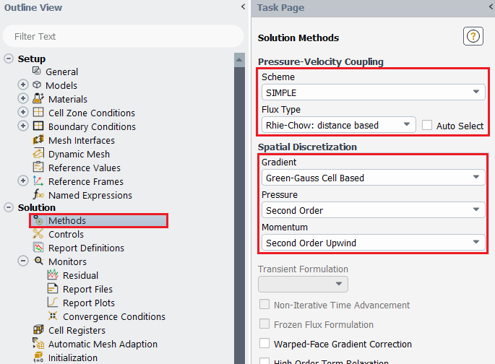
Turbulent flow
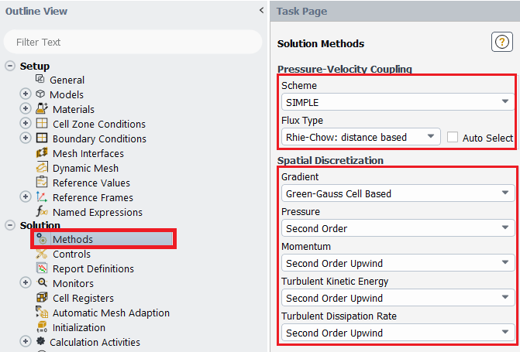
  - Tree > Solution > Monitors > Residual (double click). Change convergence criterion to 1e-6 for all three and five equations as per below for laminar and turbulent cases respectively and click OK. (Note: for iterative error study you will need to use 1e-5)
Laminar flow
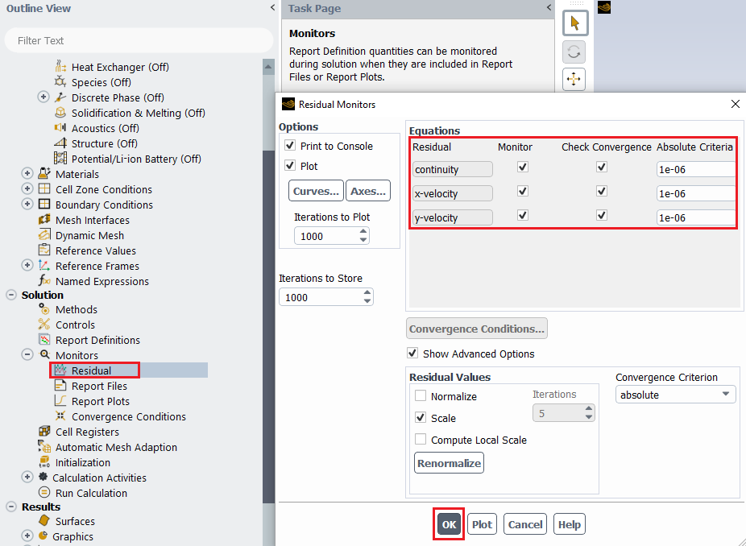
Turbulent flow
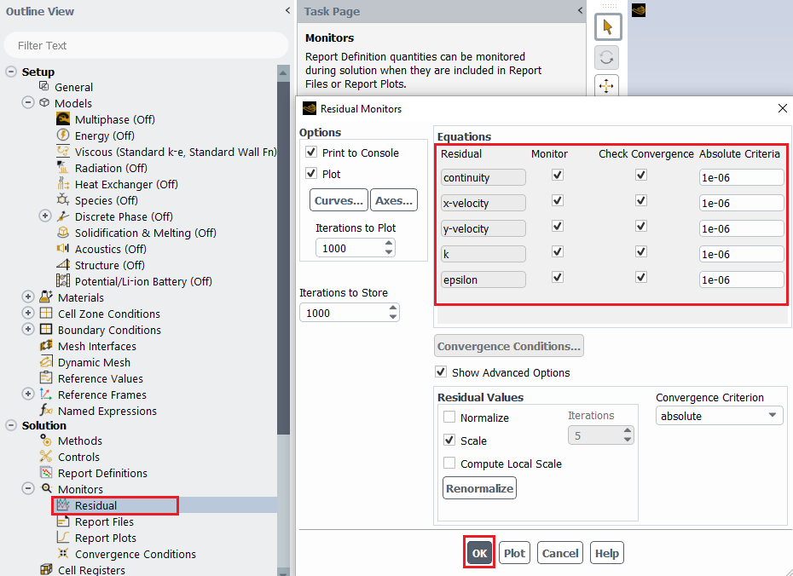
  - Tree > Solution > Initialization. Change parameters as per below and click Initialize.
Laminar flow
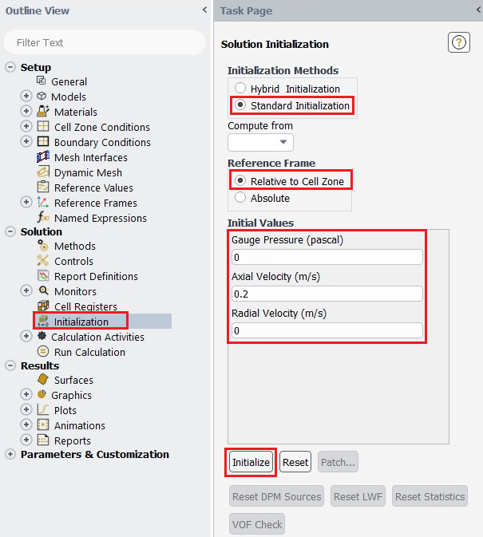
Turbulent flow 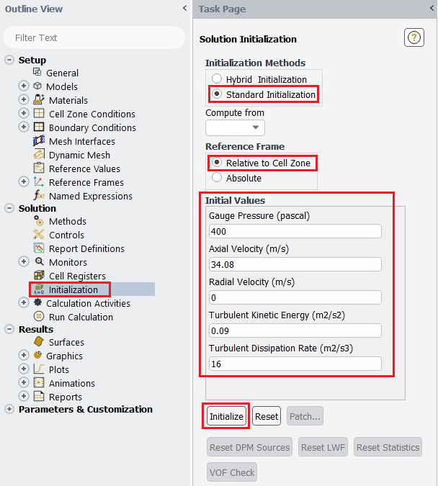

  - Tree > Solution > Run calculation. Change number of iterations to 1000 and click Calculate.
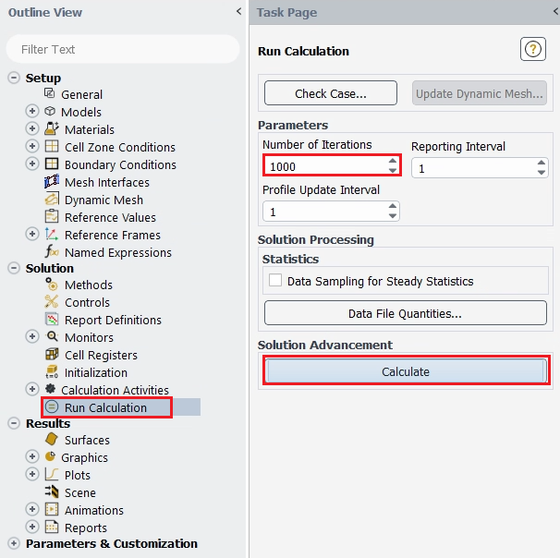

  - File > save project. Make sure to save the project for later use.

- Results

This section shows how to analyze your results in Fluent. You do not need to do all of the analysis for every case. Please refer to exercises at the end of this manual to determine what analysis you need to do for each simulation.

  - Saving Picture
File > Save Picture. Your current display can be saved as a picture file by adjusting formats or resolutions like below and by clicking Save. Use this function whenever you need to save pictures for the report.
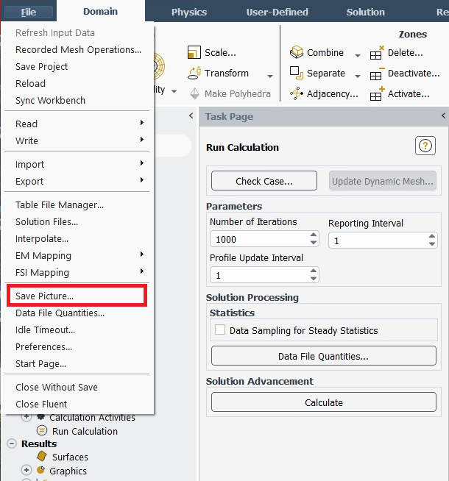
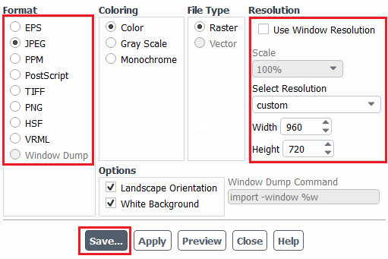
  - Displaying Mesh
Setting Up Domain > Display. Select all the surface you want to display. Lines and points you create can be displayed here as well.
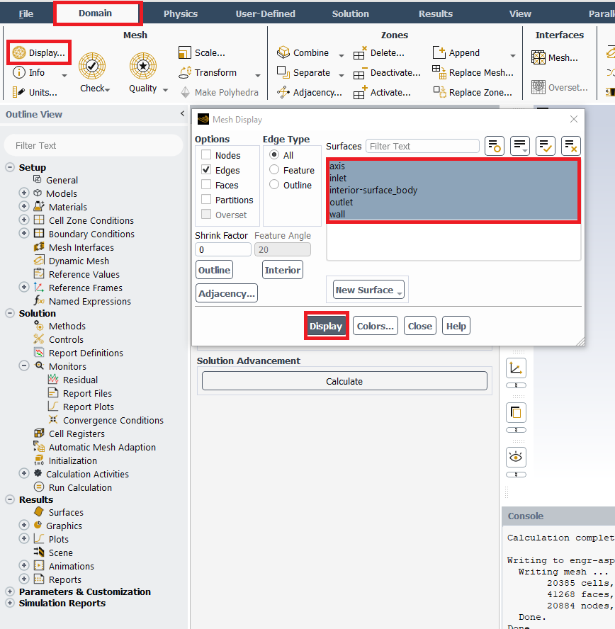

*Tips
Zoom in and zoom out: Scroll up/down mouse wheel
Move: Move the mouse with holding mouse wheel

  - Plotting Residuals
Refer 6.15. Click Plot next to Ok. Residual plot for laminar case is at below as an example.
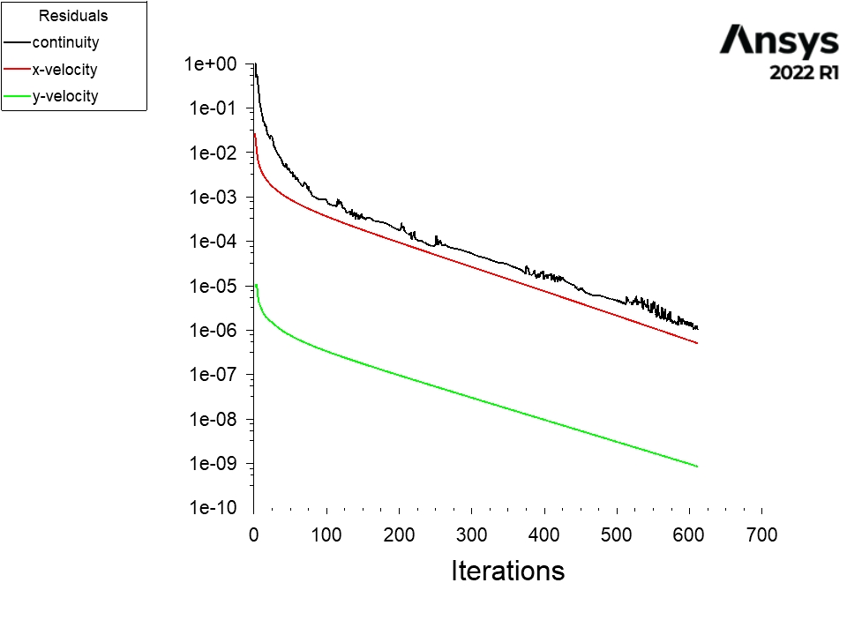

  - Creating Points
Setting Up Domain > Surface > Create > Point. Change x and y values as per below click Create. Repeat this for other lines shown in the table below.
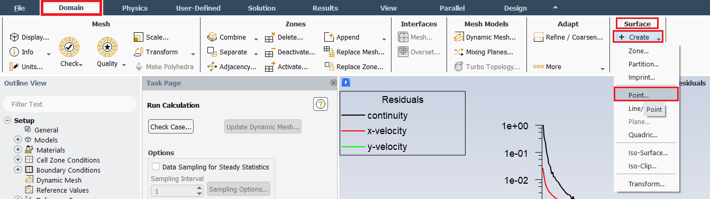
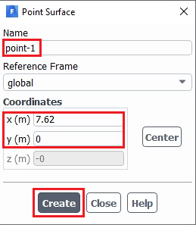
Point Name | x0 | y0
point-1 | 7.62 | 0.000
point-2 | 7.62 | 0.005
point-3 | 7.62 | 0.010
point-4 | 7.62 | 0.015
point-5 | 7.62 | 0.020
point-6 | 7.62 | 0.021
point-7 | 7.62 | 0.022
point-8 | 7.62 | 0.023
point-9 | 7.62 | 0.024
point-10 | 7.62 | 0.025

  - Creating Lines
Setting Up Domain > Surface > Create > Line/Rake. Change x and y values as per below click Create. Repeat this for other lines shown in the table below.
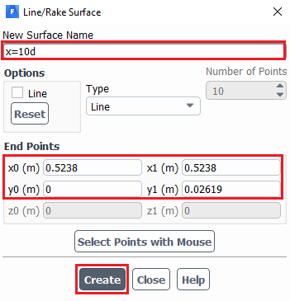
Surface Name | x0 | y0 | x1 | y1
x=10d | 0.5238 | 0 | 0.5238 | 0.02619
x=20d | 1.0476 | 0 | 1.0476 | 0.02619
x=40d | 2.0952 | 0 | 2.0952 | 0.02619
x=60d | 3.1428 | 0 | 3.1428 | 0.02619
x=100d | 5.2380 | 0 | 5.2380 | 0.02619

  - Plotting Velocity Profile
Tree > Results > Plots > XY Plot (double click). Select inlet, outlet, and the lines you created and change setting as per below then click Plot.
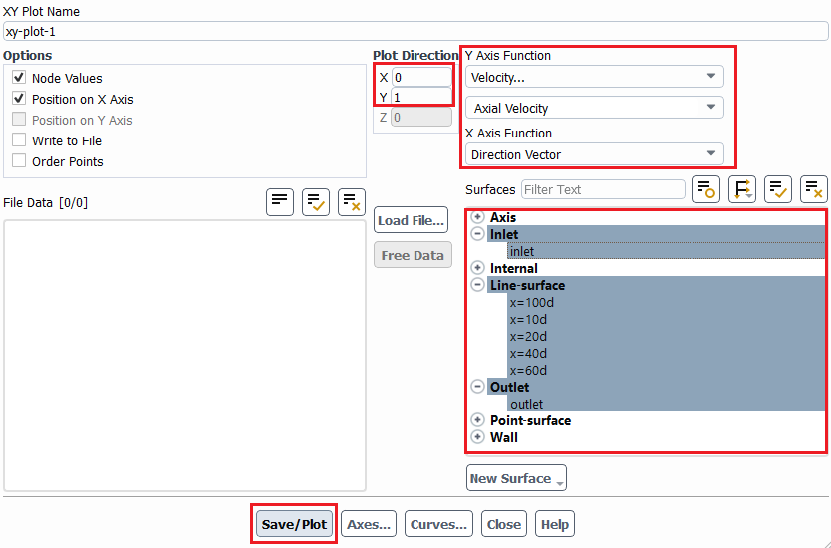

Tree > Results > Plots > XY Plot (double click) > Curves. For Curve # 0 select the Line Style Pattern, Line Style Color as per below and click Apply. Repeat this for all the curves 1 through 7.
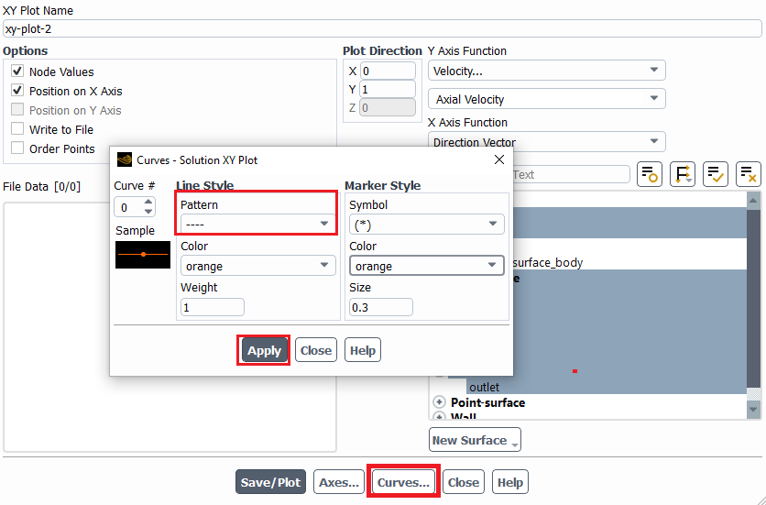
Download the experimental data for the simulation from the class website:
[Right mouse button-> Save link as..]
(http://user.engineering.uiowa.edu/~me_160/CFD%20Labs/Lab1/axialvelocityAFD-laminar-pipe.xy)
(http://user.engineering.uiowa.edu/~me_160/CFD%20Labs/Lab1/axialvelocityEFD-turbulent-pipe.xy)
Tree > Results > Plots > XY Plot (double click) > Load File. Select “axialvelocityAFD-laminar-pipe.xy” (if laminar) or “axialvelocityEFD-turbulent-pipe.xy” (if turbulent) downloaded and click Plot.
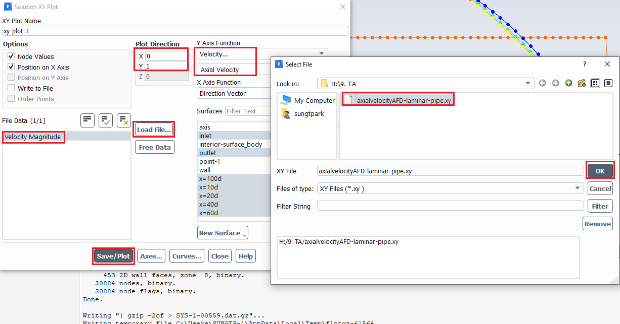

Result for laminar flow is presented as an example below.

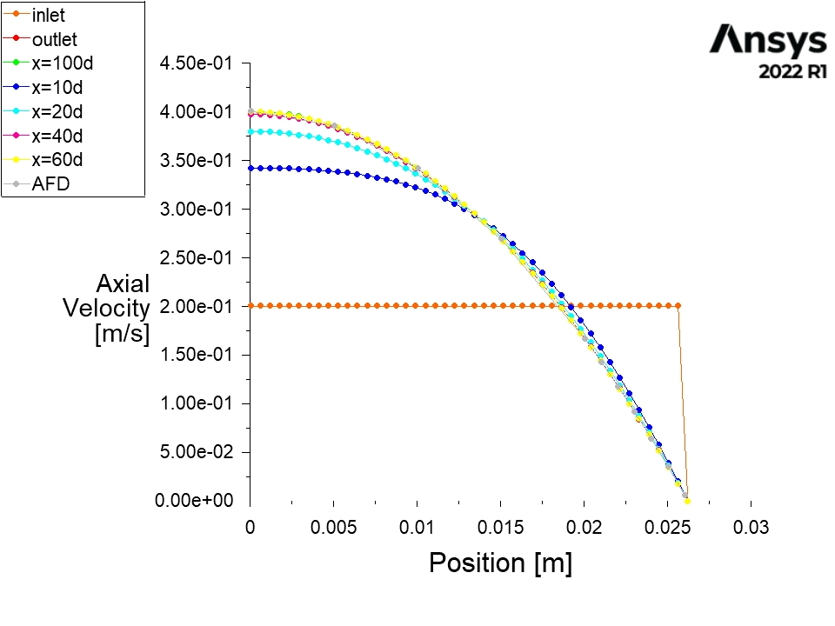

  - Plotting Static Pressure Profile at Centerline
Tree > Results > Plots > XY Plot (double click). Change Y function to Pressure… and select axis then click Plot.
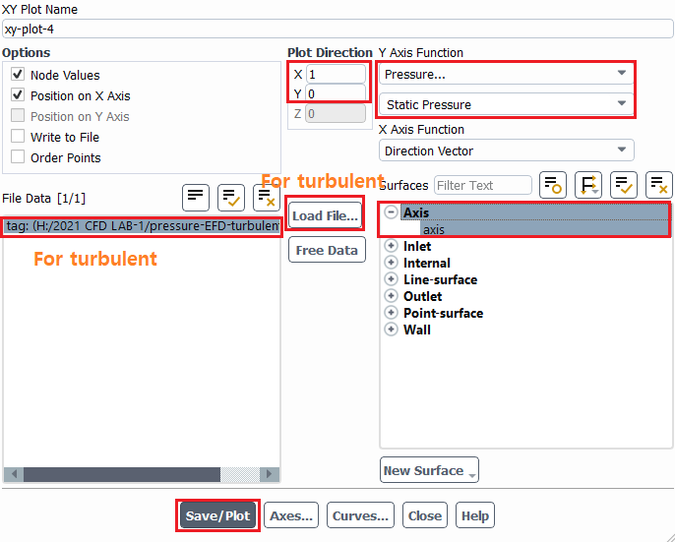

For the turbulent case, download the experimental data for the simulation from the class website (https://stern.lab.uiowa.edu/me51600001-intermediate-mechanics-fluids -> pressure-EFD-turbulent-pipe.xy).

(Turbulent case continued) Tree > Results > Plots > XY Plot (double click) > Load File. Select “pressure-EFD-turbulent-pipe.xy” downloaded and click Plot.

Result for laminar flow is presented as an example.
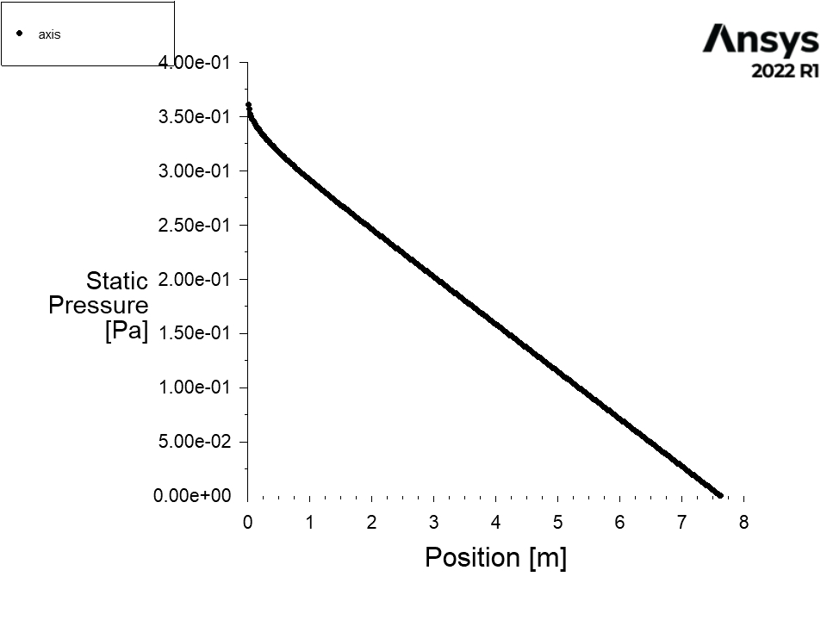
  - Plotting Velocity at Centerline
Tree > Results > Plots > XY Plot (double click). Change Y function to Velocity… and Axial Velocity. Select axis then click Plot. Change Plot Direction as below if necessary.
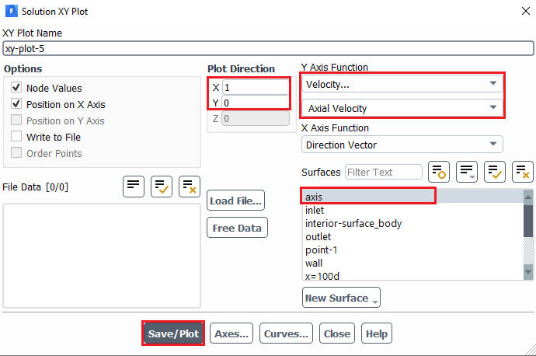

Example for the laminar case is presented.

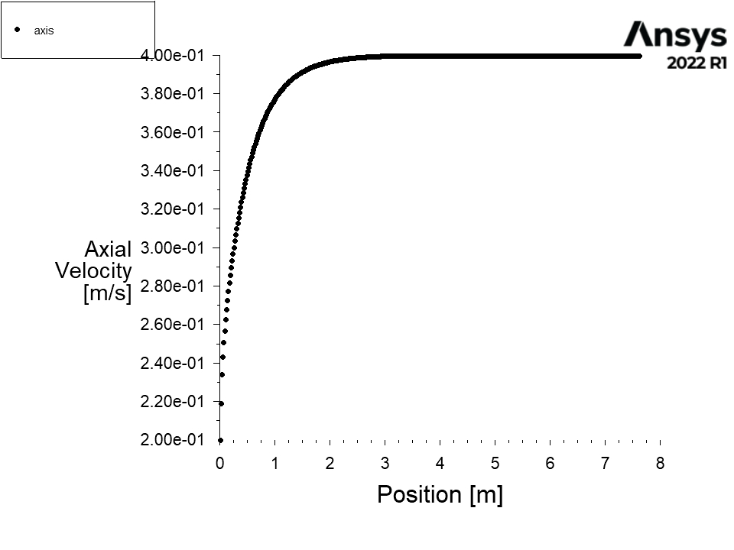

  - Exporting Wall Shear Stress Values
Tree > Results > Plots > XY Plot (double click). Change Y function to Wall Fluxes… and Wall Shear Stress. Select wall then click Write to File to enable Write. Click Write to export the shear stress along the wall of the pipe. You will need this data to compute the shear stress coefficient at the developed region.
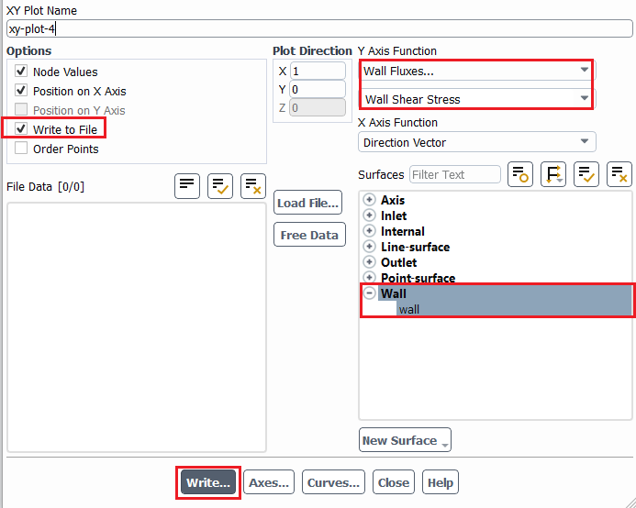

  - Plotting Velocity Vectors
Tree > Results > Graphics > Vectors (double click). Change the vector parameters as per below and click Display.
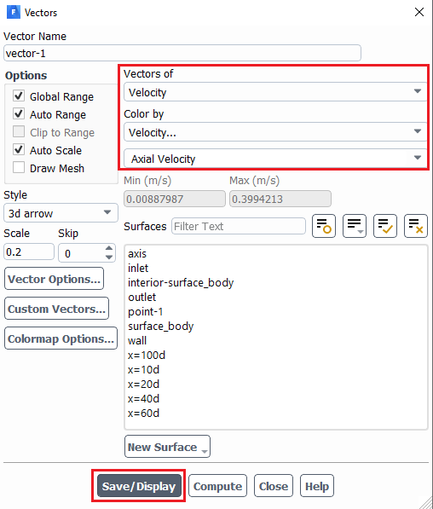

Result of laminar flow is presented as an example.

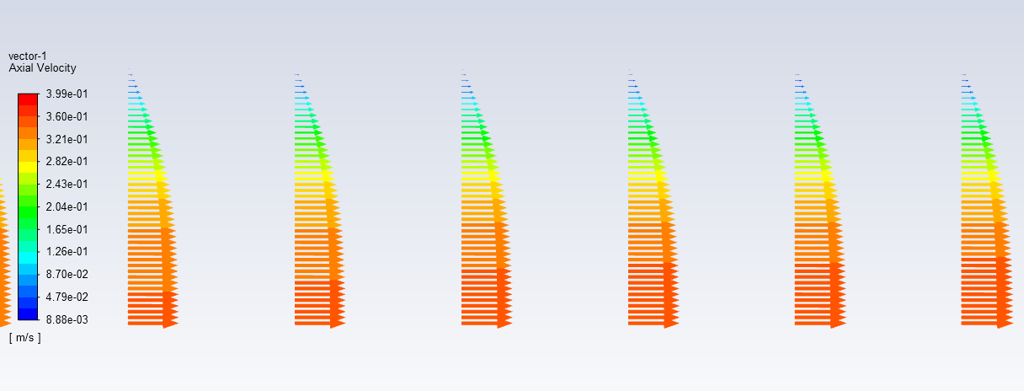
  - Plotting Velocity Contours
Tree > Results > Graphics > Contours (double click). Change the parameters as per below and click Display.
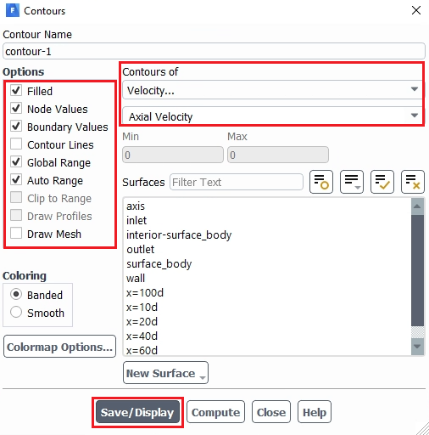

Result of laminar flow is presented as an example.
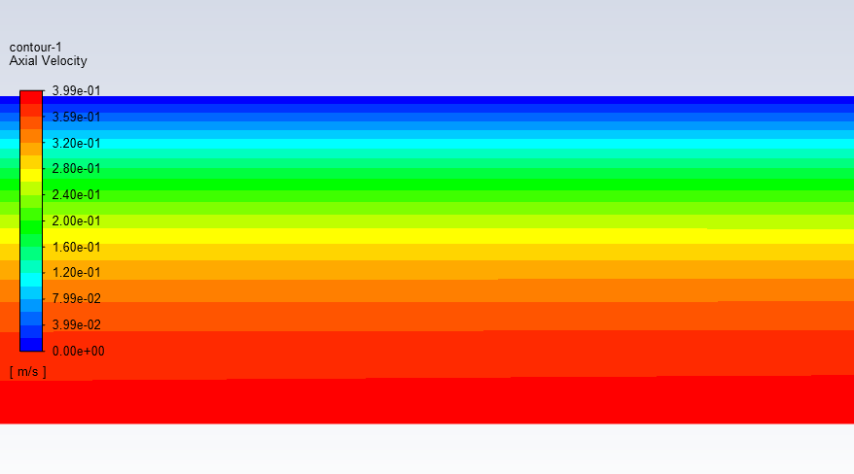

If the plot does not show up well, remove the plot window, and use a ‘Display’ button as below.
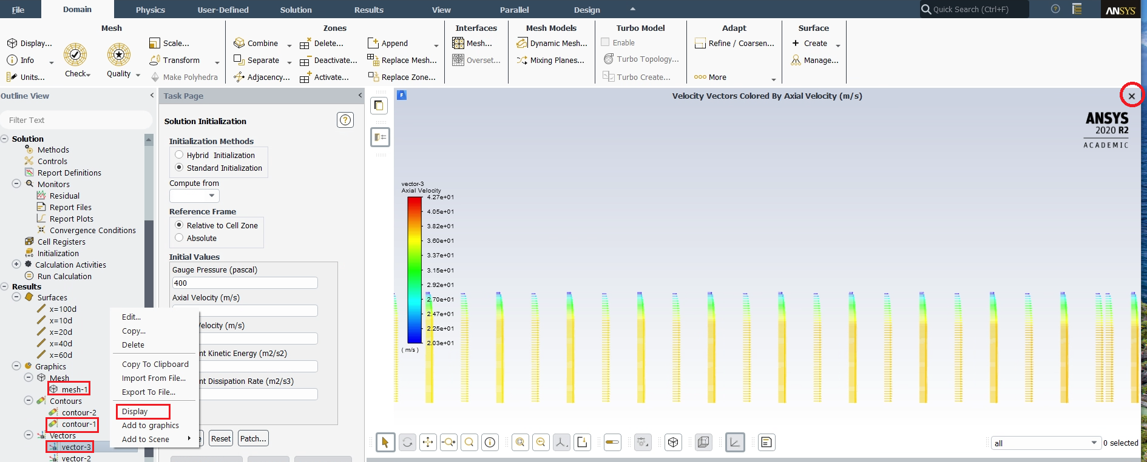

- V&V Instructions
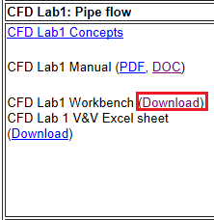
  - V&V Instructions for Velocity Profile

Download CFD Lab 1 Workbench file from class website

Click update project button. This will run all the simulation on the workbench file and it may take few minutes.
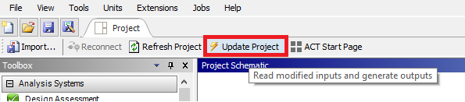
Right click Solution > Select Edit…

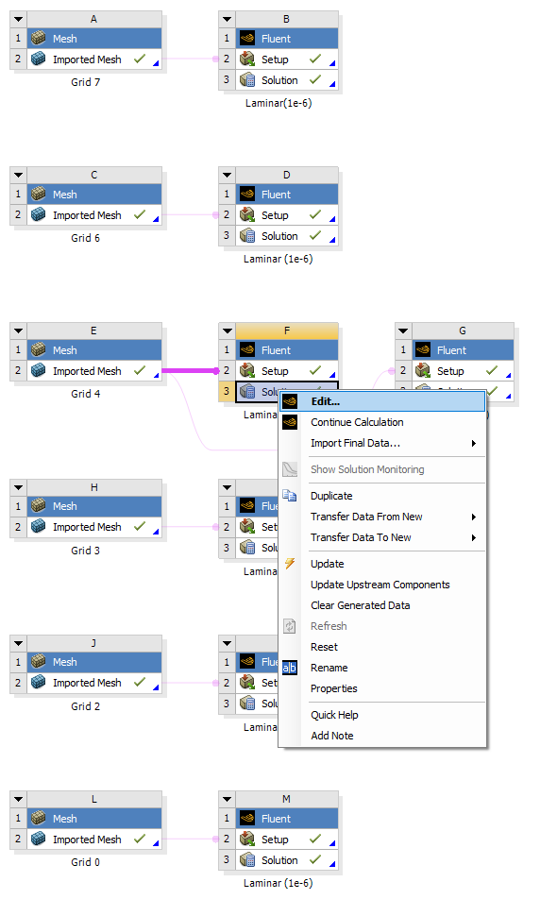
Create reference points by following 7.4.
Tree > Results > Plots > XY Plot (double click). Change parameters as per below and click Write… Make sure to select points 1 through 10.
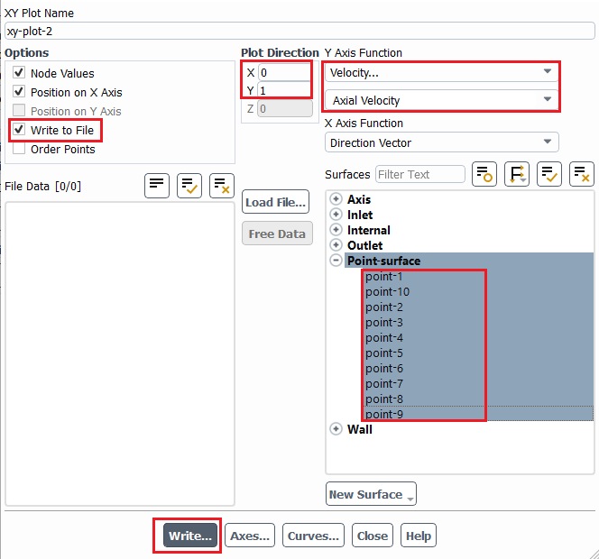

Name file according to which grid solution you are using.
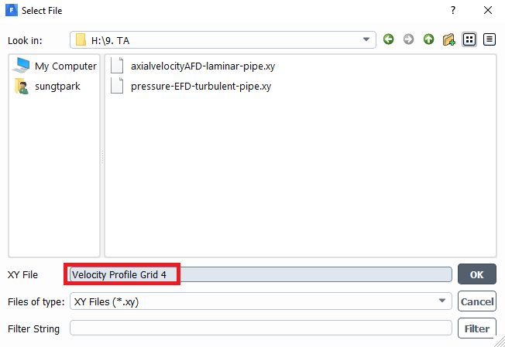
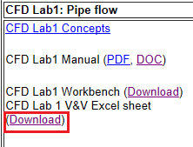
Download V&V excel sheet for CFD Lab 1 from class website (https://stern.lab.uiowa.edu/sites/stern.lab.uiowa.edu/files/2024-11/Intermediate%20Lab%201%20V%26V%20Student_0.xlsx)
Open file using Textpad/Wordpad/Notepad, copy points to input into V&V Excel file.
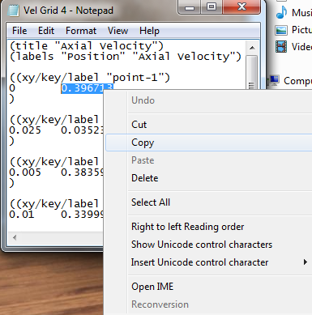
Paste value into V&V Excel file according to its y position and its grid number. Use the Keep Text Only paste function by right clicking in the cell and selecting it from the paste options.
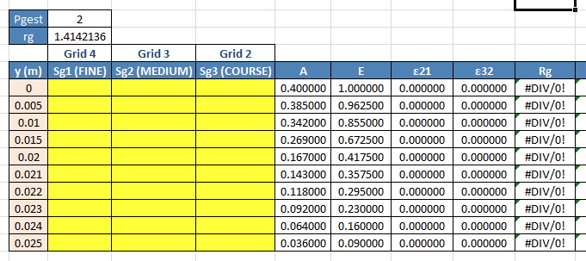
Repeat this process for the remaining y location points and then the two remaining grid solutions. All yellow cells should be filled.
  - V&V Instructions for the Friction Coefficient
Right click Solution > Select Edit…
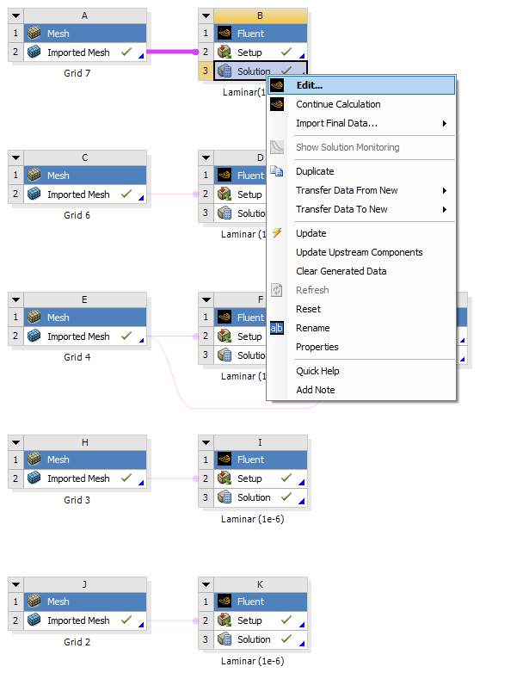

Tree > Results > Plots > XY Plot (double click). Change parameters as per below and click Write…
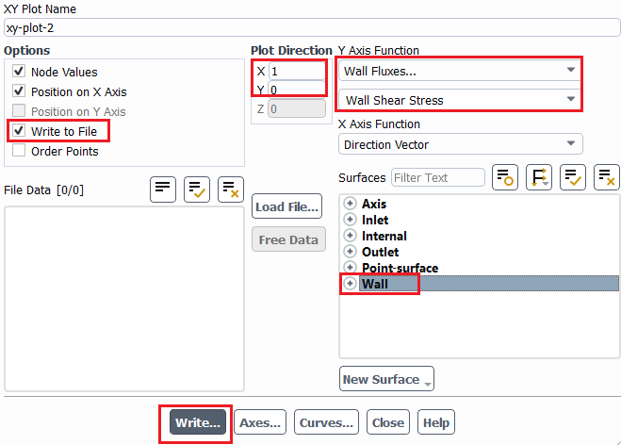
Name the file according to grid number and save to project folder.
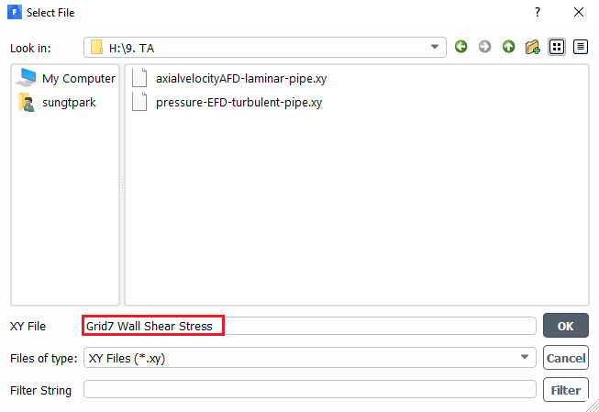

Open file with a text editor such as Textpad/Wordpad/Notepad and copy wall shear stress at the x location of approximately 7m.
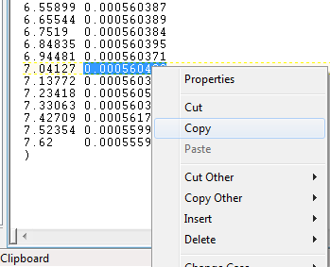

Paste the value into corresponding cell in the V&V template.
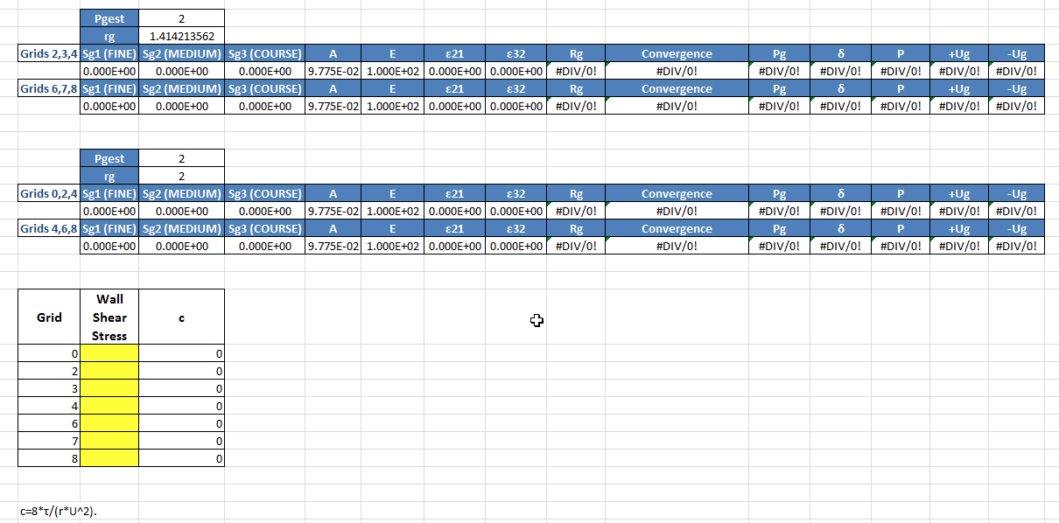

Make sure when pasting you select Keep Text Only and you select the proper cell corresponding to the grid number.
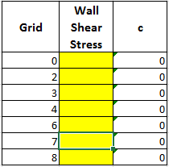

Repeat this process for the remaining six grids. Each yellow cell should be filled.

- Data Analysis and Discussion

You need complete the following assignments and present results in your lab reports following the lab report instructions.

* 9.1.-9.4. and 9.6. are for laminar flows, 9.5. is for turbulent flows

  - Iterative error studies (+6)

Use grid 4 and 8 with laminar flow conditions. Use two different convergent limits 10⁻⁵ and 10⁻⁶ and fill in the following table for the values on friction factors (grid 4 is given on workbench file which can be found on the class website). Find the relative error between AFD friction factor (0.097747231) and friction factor computed by CFD, which is computed by:

To get the value of${ Factor}_{CFD}$, you need to export wall shear stress data. Then use the wall shear stress at the developed region to calculate the friction factor. The equation for the friction factor is C=8*τ/(r*U^2), where C is the friction factor, $τ$ is wall shear stress, r is density and U is the inlet velocity. Discuss the effect of convergent limit on results for these two meshes

Mesh No. | Friction Factor  with Convergence  Limit 1e-5 | Relative Error with Convergence  Limit 1e-5 | Friction Factor with Convergence  Limit 1e-6 | Relative Error  with Convergence  Limit 1e-6
4
8

- Figure need to be reported: residuals history for mesh 8 for two convergent limits.
- Data need to be reported: the above table with values for friction factor and relative error.

  - Verification study for friction factor of laminar pipe with refinement ratio √2 (+7)

Use the simulations with the meshes for grid 2, 3, 4, 6, 7, and 8 with convergence limit 10⁻⁶ (Except for mesh 8 other meshes and their setup is provided on the workbench file in the class website). Export friction factor and insert the values into V&V excel sheet (Refer to V&V instructions for friction factor). For each parameter, refer to ‘Nomenclature’ sheet in V&V excel sheet.

Which set of meshes is closer to the asymptotic range and why (refer to CFD Lecture 1 on class website)? Which set has a lower grid uncertainty (Ug)? Which set is closer to the theoretical value of order of accuracy (2nd order)? For the fine mesh 8, also compare its relative error of the friction factor (the one using convergent limit 10⁻⁶ in the table in exercise 8.1) with the grid uncertainty for 6,7,8, which is higher and what does that mean for mesh 8?
- Figure need to be reported: Table from V&V spread sheet.

  - Verification study for friction factor of laminar pipe with refinement ratio 2 (+5)

Use the simulation for the meshes 0, 2, 4, 6 and 8 with convergence limit 1e-6. Results should already be included in V&V spread sheet from previous exercise (Refer to V&V instructions for friction factor). Compared to results in 9.2, which set of meshes is sensitive to grid refinement ratio? Why?
- Figures need to be reported: Table from V&V spread sheet.

  - Verification study of axial velocity profile (+7)

Use mesh 4 as the “fine mesh”, use grid refinement ratio 1.414 and convergence limit 10⁻⁶. Follow the V&V for axial velocity profile in the results section. Save the figures and discuss if the simulation has been verified. Discuss which mesh solution is closest to the AFD data, give an explanation of why this is the case?
- Figures need to be reported: Figures and tables in the V&V excel sheet.

  - Simulation of turbulent pipe flow using Grid T (+9)

Use simulation with convergence limit 10⁻⁶ and compare with EFD data on axial velocity profile and pressure distribution along the pipe. Export the axial velocity profile data at x=100D, use EXCEL to open the file you exported and normalize the profile using the centerline velocity magnitude at x=100D (Non-dimensionalize the profile by dividing with the reference value (For this exercise, reference value is the centerline velocity (=max. velocity)). Plot the normalized velocity profile in EXCEL and paste the figure into WORD.
- Figures need to be reported: Axial velocity profile with EFD data, normalized axial velocity profile at x=100D with EFD data, centerline pressure distribution with EFD data, centerline velocity distribution, contour of axial velocity, velocity vectors showing the developing region and developed regions.
- Data need to be reported: Developing length and compare it with that using formula in textbook.

  - Comparison between laminar and turbulent pipe flow (+9)
Compare the results of laminar pipe flow using mesh 8 in exercise 9.1 (convergent limit 10⁻⁶) with results of turbulent pipe flow in exercise 9.5. Analyze the difference in normalized axial velocity profile and developing length for laminar and turbulent pipe flows.
- Figures need to be reported: Axial velocity profile with AFD data, normalized axial velocity profile at x=100D with AFD data, normalized axial velocity profile at x=100D comparing laminar and turbulent CFD results, centerline velocity distribution for laminar flow.
- Data need to be reported: Developing length for laminar pipe flow and compared it with that using formula in textbook.

  - Questions need to be answered in CFD Lab report

    - Answer all the questions in exercises 9.1 to 9.6
    - Analyze the difference between CFD/AFD and CFD/EFD and possible error sources (+2)

- Grading scheme for CFD Lab Report

(Applied to all CFD Lab reports)

Section Points

1 Title Page 5
1.1 Course Name
1.2 Title of report
1.3 Submitted to “Instructor’s name”
1.4 Your name (with email address)
1.5 Your affiliation (group, section, department)
1.6 Date and time lab conducted
2 Test and Simulation Design 10
Purpose of CFD simulation
3 CFD Process 20
Describe in your own words how you implemented CFD process
(Hint: CFD process block diagram)
4 Data Analysis and Discussion Section 9 (Page# 51) for CFD Lab 1 45
Answer questions given in Exercises of the CFD lab handouts
5 Conclusions 20
Conclusions regarding achieving purpose of simulation
Describe what you learned from CFD
Describe the “hands-on” part
Describe future work and any improvements
Total 100

Additional Instructions:

- Each student is required to hand in individual lab report.
- Conventions for graphical presentation (CFD):
* Color print of figures recommended but not required
3. Reports will not be graded unless section 1 is included and complete

