57:020 Mechanics of Fluids and Transfer Processes
Laboratory Experiment #3

Measurement of Pressure Distribution and Forces Acting on an Airfoil

S. Ghosh, M. Muste, S. Breczinski, J. Johnson, S. Cook, and F. Stern

1. Purpose
The purpose of this investigation is to measure the surface pressure distribution, wake axial velocity profile, and lift and drag forces on a Clark-Y airfoil set at two angles of attack (0 and 16 degrees), and to compare the results, including their uncertainties, with benchmark data. The experiment will also introduce students to concepts related to digital acquisition systems: calibration, noise, settling time, and sampling time. Additionally, this laboratory will provide students with further analysis using an image-based system (ePIV/FlowCoach) with two Clark-Y airfoil models at angles of attack 0 and 16 degrees.

2. Experiment Design

2.1. Part 1: Wind Tunnel
The geometry of and forces acting on a generic airfoil in a constant flow field (U∞) are shown in Figures 1a and 1b. These experiments are conducted using a Clark-Y airfoil mounted in the test section of a closed circuit, open test section, and vertical return wind tunnel (Figure 2). The tunnel enables measurements for turbulent flows up to Re = 300,000. (Re = U∞c/ ν, where U∞ is the free-stream velocity in the tunnel, c is the airfoil chord length, and ν is the kinematic viscosity of air). It has four 90º corners equipped with turning vanes, two diffusers, a contraction section, test section and fan. The vanes, settling chamber and contraction section help in achieving a uniform flow in the test section.

- Geometry | - Hydrodynamics
Figure 1. (a)-(b): Airfoil characteristics

(a) Layout of the open test section wind tunnel |  | (b) Airfoil schematic  showing measurement system components
Figure 2 (a)-(b): Wind tunnel layout

The tunnel’s closed circuit is approximately 18.3 m long. The test section is a 0.76 m by 0.76 m square, 1.52 m long. A resistance temperature detector and a Pitot tube are placed upstream in the upper half of the test section to monitor and control the temperature and free stream velocity, respectively. The Pitot tube is connected to a pressure transducer along with a digital display for visualization of experimental conditions. A Clark-Y airfoil was selected for the experiment because it exhibits good aerodynamic performance over a wide range of Reynolds numbers and also because there is abundant benchmark data available for comparison. The geometry of the Clark-Y airfoil and the positioning of the pressure taps used in the experiment are illustrated in Figure 3b. Positioning of the airfoil at various angles of attack is made with a hand wheel connected to a digital display. The airfoil is set on a pair of load cells that measure the overall forces (lift and drag) acting on the airfoil (see Figure 3a and 3c). An overall view of the system is provided in Figure 3a.
Data acquisition is conducted with an Automated Data Acquisition System (DA), as shown in Figure 3c. DA is controlled and interfaced by LabView software, described in Appendix B. DA contains several measurement modules: tunnel controls, pressure measurements, velocity measurements, and force measurements. The pressure distribution around the airfoil is obtained from 29 pressure taps, connected, using tygon tubes, to the ports of a scanning valve that sequentially cycles through each pressure tap. Pressures selected by the scanning valve are measured by a differential pressure transducer that has one port connected at all times to the pressure measured in the free stream (p∞), with the other port connected to the scanning valve output port. The wake velocity profile is measured with a traverse-mounted Hot-wire and a Pitot tube with stagnation pressure routed through one of the scanning valve input ports. The automated traverse allows for consistent and efficient velocity measurements at specified vertical positions with the use of the DA. The load cell measures forces directly applied to the airfoil. It is calibrated during the experiment to obtain a relationship between forces acting on the airfoil and voltage output from the load cell.
(a)  (b)  (c)  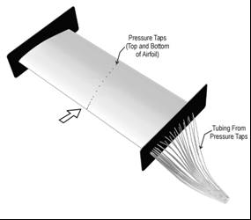 | 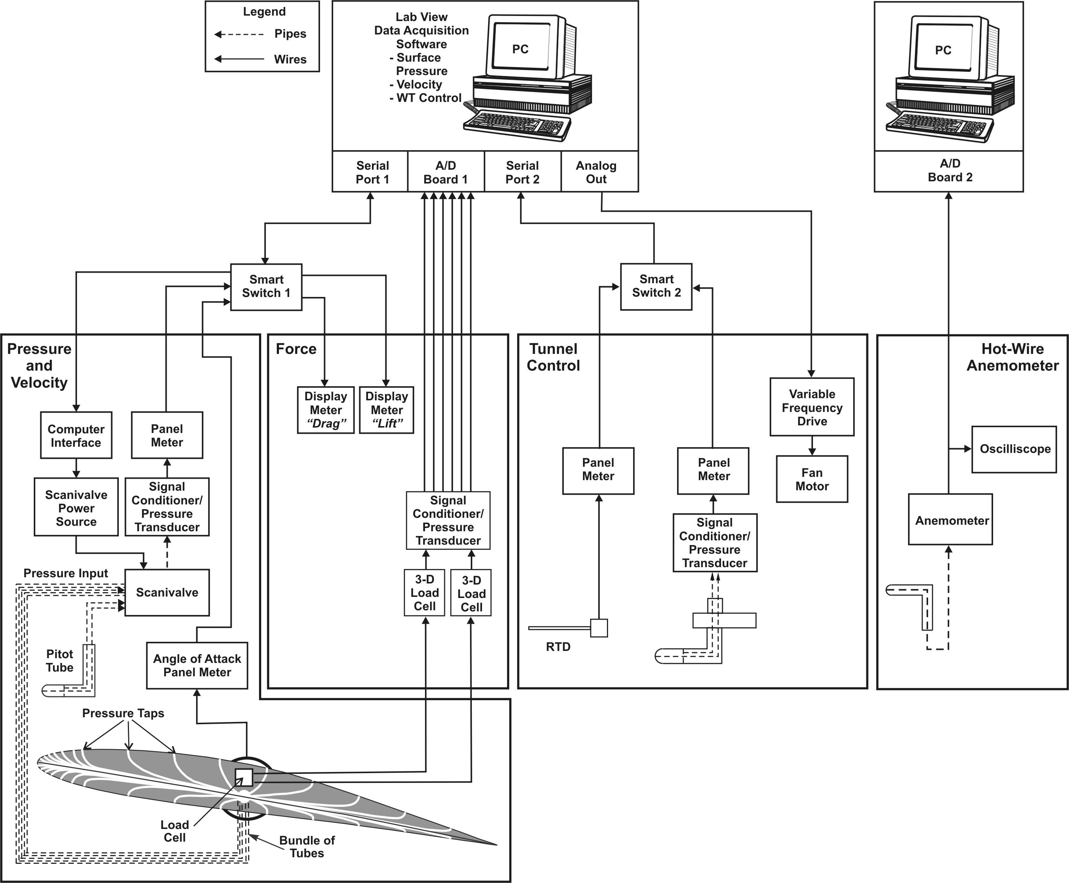
Figure 3: Experimental layout: a) photograph of test section and instrumentation;
b) Clark-Y airfoil geometry; c) DA components

2.1.1. Data reduction (DR) equations
The measured variables are the test section air temperature, free stream velocity, pressure distribution around the airfoil, axial velocity profile behind the airfoil, and lift and drag forces acting on the airfoil. Using these measurements, the pressure coefficients at each pressure tap, CP, and the lift coefficient for the airfoil, CL, are obtained. The data reduction equation for the pressure coefficient, C_{P}, is given by:

 | $$C_{p}\left[p_{i},p_{∞},ρ,U_{∞}\right]=\frac{2\left(p_{i}−p_{∞}\right)}{{ρU}_{∞}^{2}}$$ | (1)
where p_{i} is the static pressure at any pressure tap on the airfoil surface, p∞ is the free stream pressure (measured on the Pitot static port), ρ is air density, and U∞ is the free-stream velocity, given by:

 | $$U_{∞}=\sqrt{\frac{2\left(p_{\text{stagn}}−p_{∞}\right)}{ρ}}$$ | (2)
where p_{stagn} is the stagnation pressure measured at the tip of the Pitot tube placed at the upper half of the test section.
The data reduction equation for the lift coefficient, C_{L}, is given by:

 | $$C_{L}\left[L,ρ,U_{∞},b,c\right]=\frac{2L}{{ρU}_{∞}^{2}\text{bc}}$$ | (3)
where L is the lift force acting on the airfoil surface, b is the airfoil span, and c is the airfoil chord (as shown in Figure 1a). The data reduction equation for the drag coefficient C_{D} is given by:

 | $$C_{D}\left[D,ρ,U_{∞},b,c\right]=\frac{2D}{{ρU}_{∞}^{2}\text{bc}}$$ | (4)
where D is the drag force acting on the airfoil surface. The lift force, L, can be obtained in two ways. The first method is by integrating the measured pressure distribution over the airfoil:

 | $$L=\int_{s}{\left(p_{i}−p_{∞}\right)}\text{sin}\left(θ_{i}\right)\text{ds}$$ | (5)
where θ_{i} is the angle of the surface normal to free-stream flow at each of the pressure taps (Figure 3b), as specified in Appendix A. The drag force, D, can also be obtained in two ways. The first method is by measuring the velocity distribution upstream and downstream of the airfoil body. Drag is then found by integrating the change in momentum:

 | $$D=ρ\int_{y_{L}}^{y_{U}}{u_{i}}\left(U_{∞}−u_{i}\right)\text{dy}$$ | (6)
where u_{i} is the velocity measured at each pre-determined elevation in the wake of the airfoil, y_{L} is the lower most elevation of the measurements, and y_{U} is the upper most elevation of the measurements. Refer to Method 2 in Appendix C for the derivation of equation (6). Alternatively, both the drag and lift forces can be directly measured with the load cell using the following calibration equations:

 |  | $$D=A_{D}⋅(V−V_{0})$$ | (7) |  |  |  | $$L=A_{L}⋅(V−V_{0})$$ | (8)

where A_{D} and A_{L} are coefficients for drag and lift, respectively, determined from the load cell calibrations, V and V₀ are the load cell voltage output when U∞ ≠ 0 and U∞ = 0, respectively.

2.2. Part 2: ePIV/FlowCoach

As in EFD Lab 2, Particle Image Velocimetry (PIV) will be used to track fluid motion and calculate velocity magnitudes and vectors around a Clark-Y airfoil at angles of attack of 0º and 16º. Data will be gathered using an ePIV (Educational PIV) system or a FlowCoach system, depending on the lab section.
In ePIV/FlowCoach analysis, a seeded fluid is illuminated by a laser sheet, and a camera takes rapid photographs of the fluid flow, at a rate of 30 Hz. Four parameters are used to control the camera settings:
- Brightness – This controls the overall brightness of the image. For the best PIV results, brightness should be set to a medium-low value.
- Exposure – This controls how long the camera sensors are exposed per image frame taken. Higher values correspond to shorter exposure times, and lower values correspond to longer exposure times. PIV analysis benefits from high exposure values (short exposure times), to facilitate software tracking of patterns of particles.
- Gain – This controls the sensitivity of the sensors per unit time. Using higher gain will amplify the signal obtained by the sensors, so typically higher gain values are needed for images taken with short exposure times, which would otherwise be very dark. However, increasing the gain has a side effect: using higher gain increases the noise in the image.
- Frames – This specifies how many images the camera will take, for PIV analysis. At least two images are needed to process vectors, and taking more will allow the software to average results and reduce precision error.
After images are captured, they are processed to determine velocity vectors and magnitudes. The software takes a pair of consecutive images and breaks it into many small regions, called interrogation windows. In each interrogation window, the PIV software compares the two images, determines how far the pattern of particles has moved in the amount of time between the two images, and calculates a single velocity vector for that window. This is repeated across the entire measurement area, generating a vector field. With the ePIV system, three PIV parameters can be adjusted.
- Window Size – This sets the size (in pixels) of the interrogation window. Ideally, smaller windows are desired, because they show more flow detail, averaging over a smaller region of the flow. However, if values are too small, fewer particles pass through the interrogation window, which can result in unstable vector computation.
- Shift Size – This determines the distance (in pixels) that the software moves to start a new interrogation window. For example, if a window size of 80 and a shift size of 40 were used, the software would compute a vector in the first 80x80 interrogation window, and then shift 40 pixels, computing a second vector in a new 80x80 window. The two windows would overlap by 50%. A smaller shift size results in more vectors being computed, but the increased overlap means that some of the data reported is repeated between the vectors.
- PIV Pairs – This specifies how many pairs of images are used for PIV calculations. PIV analysis compares any two consecutive images, if 10 images are captured; up to 9 PIV pairs can be specified for computation. Results computed for each individual pair are averaged together, reducing precision error.

3. Experiment Process

3.1. Part 1: Wind Tunnel

Figure 4: EFD Process for Wind Tunnel Measurements.

3.1.1. Test Setup
The experiment measurement system is comprised of the wind tunnel, the airfoil, and the DA (see Figure 3). The DA acquires measurements velocities and temperature in the test section, pressures on the surface of the airfoil, forces on the airfoil, and the angle of attack. Before taking the measurements there are several preparatory operations:
Load cell calibration
- Install the model in the test section and set it to zero angle of attack.
- With wind tunnel velocity set to zero, calibrate the load cell. The load cell measures three force components, i.e., Fx (the drag force), Fy and Fz (the lift force). Calibrations are only conducted for lift and drag forces. For this purpose, a series of five loads (from 0 to 1.635 kg) will be successively applied to a special calibration frame, as demonstrated by the TA. Open the calibration software and follow the instructions specified in Step 1, Appendix B. Using the software, plot the measurements. Calibration coefficients will later be calculated by applying a linear regression to the measured data.

Tunnel flow conditions
- Set the target flow conditions in the tunnel test section, as per Step 2, Appendix B. A Reynolds number of 300,000 (15 m/s free stream velocity) will be used in this experiment to compare results with the available benchmark data.
Pressure transducer operation
- With tunnel settings at the target conditions (Re=300,000), software will be used by the TA to demonstrate the effect of the noise of DA. This noise takes the form of a residual signal in the DA recordings that collectively represents the electronic noise, digitization effects, other uncontrolled environmental parameters, and the effect of the digitization levels: the resolution with which the DA converts the analog to digital signal.
- Two important data acquisition parameters will be established, using another set of software interfaces. The settling time (time needed for the DA to recover after changing its setting from one pressure tap to the next) and the sampling time (the length of time needed for a measurement to capture the actual mean value of a turbulent, fluctuating quantity) will be explained and demonstrated by the TA.

3.1.2. Data Acquisition
The data acquisition steps are listed below:
- Install the airfoil, and calibrate the load cell for both lift and drag forces, following Step 1, in Appendix B.
- Set the airfoil angle of attack to 0°, and adjust the wind tunnel motor speed to achieve a Reynolds number of 300,000 (15 m/s free stream velocity). Details are specified in Step 2, Appendix B.
- With the flow and angle of attack set to the desired values, measure the lift and drag forces on the airfoil, using the load cells. Open the Labview program for load cell data acquisition and follow the procedure in Step 4, Appendix B. The software records the voltage output from the load cells. These voltage values will be converted to forces using the calibration equation (equation (7) and (8)) and the established calibration coefficients.
- Maintaining the same flow conditions as above, measure the pressure distribution around the airfoil. Open the Labview program for the pressure transducer, and follow the procedure in Step 3 of Appendix B. Enter the values of the settling and sampling determined above in the software interface. The DA software will measure the pressure distribution around the airfoil, as well as the free-stream velocity. Pressure is measured in reference to the static pressure tap on the traverse-mounted Pitot tube. For this reason, ensure the Pitot tube is positioned well below the airfoil with the use of the traverse. The TA will demonstrate the proper use of the traverse controller. The software outputs the average pressure measured at each tap and graphically displays the measurements as they are collected. The input connections to the scanning valve are as follows:
  - Ports 0 to 28 are connected to the corresponding pressure taps located on the airfoil (see Figure 3.b).
  - Port 40 is connected to the static pressure tap on the traverse mounted Pitot tube (which is connected to the reference side of the pressure transducer, and is therefore redundant).
  - Port 42 is connected to the stagnation pressure tap on the traverse-mounted Pitot (for velocity measurement, step 6 below).
- For angle of attack of 0° with the same flow conditions as in step 2, measure the velocity profile downstream of the airfoil. Before acquiring data it is important to establish a datum for which to reference the elevation of traverse-mounted Hot-wire and Pitot tube. Use the traverse controller to position the tip of the Hot-wire and Pitot at the same elevation as the trailing edge of the airfoil. It is important to consult the TA for proper traverse controller operation. Open the Labview program for velocity profile measurement, and follow the procedure in Step 5 of Appendix B. The DA software will measure the Hot-wire sensed voltage and pressure difference sensed by the Pitot tube and will internally convert both voltage and pressure difference to a velocities. Velocities from the Hot-wire and Pitot measurement are graphically displayed at each pre-determined elevation (defined in DA) allowing the velocity profile to be visualized.
- Repeat Steps 2 through 5 for an angle of attack of 16°.

3.1.3 Data Reduction
A spreadsheet will be provided for the data reduction. Data reduction includes calculation of the following quantities:
- Calculate C_{p} for all 28 pressure taps.
- Calculate the lift force L and the corresponding lift coefficient C_{L} on the airfoil by integrating the measured pressure distribution over the airfoil surface.
- Calculate the lift force L and the corresponding lift coefficient C_{L} on the airfoil using data obtained from the load cell.
- Calculate the drag force D and the corresponding drag coefficient C_{D} on the airfoil using data obtained from the load cell.
- For each angle of attack, calculate the drag force D and the corresponding drag coefficient C_{D} on the airfoil by integrating the change in momentum from the measured velocity profile downstream of the airfoil.
- Repeat Steps 1 through 5 for an angle of attack of 16°.

3.1.4. Uncertainty Assessment
Uncertainties for the experimentally measured pressure and lift coefficients will be evaluated. The methodology for estimating uncertainties follows the AIAA S-071 Standard (AIAA, 1995) as summarized in Stern et al. (1999) for multiple tests (sections 6.1 and 6.3). The block diagram for error propagation to the final results is provided in Figure 5. Based on previous experiments, it was found that bias and precision limits forρ,$U_{∞}$,θ, s, and c are negligible, so for the present analysis, we will only include the bias limit for$p_{i}−p_{∞}$. The spreadsheet provided for calculating experimental uncertainties contains estimates of bias and precision limits for the individual measured variables, based on previous experiments.
The data reduction equation for the pressure coefficients (equation (1)) is of the form$C_{p}=f(p_{i}−p_{∞},ρ,U_{∞})$. For this analysis, we will only consider bias and precision limits for $p_{i}−p_{∞}$ (see uncertainty analysis spreadsheet). Note that this uncertainty assessment does not include error sources such as pressure lag exceeding the data acquisition delay time, undetected leaks in the pressure tubing, model orifice effects, vibration effects on the probes, unsteady flow effects, and undetected leaks in the scanning valve.  The total uncertainty for the pressure coefficient measured at each pressure tap is given by equation (24) in Stern et al. (1999):  The bias limit in Equation (8) is the same for all taps and is given by equation (14) in Stern et al. (1999). Neglecting correlated bias limits and discarding the terms with negligible bias limits: | Figure 5. Block diagram showing propagation of error through data reduction equations
   | $$U_{\text{Cp}}^{2}=B_{\text{Cp}}^{2}+P_{\text{Cp}}^{2}$$ | (8)
   | $$B_{\text{Cp}}^{2}=\sum_{i=1}^{j}{θ_{i}^{2}}B_{i}^{2}=θ_{(\text{pi}−p∞)}^{2}B_{(\text{pi}−p∞)}^{2}$$ | (9)
where B_{i} is the bias limit for the individual variable and $θ_{i}=∂C_{p}/∂X_{i}$is the sensitivity coefficient. This sensitivity coefficient$θ_{\left(p_{i}−p_{∞}\right)}$ is evaluated using the average values for the individual variables, and is given by:
 | $$θ_{\left(p_{}\right)}=\frac{∂C_{p}}{∂\left(p_{i}−p_{∞}\right)}=\frac{2}{{ρU}_{∞}^{2}}$$ | (10)
The precision limit for each pressure tap in Equation (8) was estimated using equation (23) in Stern et al. (1999):
 | $$P_{\text{Cp}}=2S_{\text{Cp}}/\sqrt{M}$$ | (11)
where S_{Cp} is the standard deviation of the pressure coefficients at each pressure tap, evaluated using equation (22) in Stern et al. (1999) for M = 10 repeated tests. Precision limits will have different values at each of the 28 taps. However, for this experiment, the precision limit will be calculated only at tap 0, where pressure measurements will be repeated 10 times.

The data reduction equation for the lift coefficient, equation (3), is of the form$C_{p}=f(p_{i}−p_{∞},θ,s,ρ,U_{∞},c)$. For this analysis, we will only consider bias and precision limits for $p_{i}−p_{∞}$ (see data reduction spreadsheet). The total uncertainty for the measurement of the lift coefficient is given by (equation 24 in Stern et al., 1999)
 | $$U_{\text{CL}}^{2}=B_{\text{CL}}^{2}+P_{\text{CL}}^{2}$$ | (12)
The bias limit in equation (12) is given by equation (14) in Stern et al. (1999). Neglecting correlated bias limits and discarding the terms with negligible bias limits:
 | $$B_{\text{CL}}^{2}=\sum_{i=1}^{j}{θ_{i}^{2}}B_{i}^{2}=θ_{(\text{pi}−p∞)}^{2}B_{(\text{pi}−p∞)}^{2}$$ | (13)
Given the above assumptions and using the lift force determined by integration (equation (5)), the expression for the bias limit of the lift coefficient is:
 | $$B_{\text{CL}}^{2}=B_{\left(\text{pi}−p∞\right)}^{2}\sum_{i=1}^{k}{{\left[\frac{∂C_{L}}{∂\left(p_{i}−p_{∞}\right)}\right]}^{2}=}{\left[\frac{B_{\left(\text{pi}−p∞\right)}}{0\text{.}5{ρU}_{∞}^{2}c}\right]}^{2}\sum_{i=1}^{k}{{\left[\text{sin}\left(θ_{i}\right){\text{ds}}_{i}\right]}^{2}}$$ | (14)
Notations used in equation (14) are defined in Table 1 and Appendix A (k = 29).
The precision limit in Equation (12) was estimated using equation (23) in Stern et al. (1999):
 | $$P_{\text{CL}}=2S_{\text{CL}}/\sqrt{M}$$ | (15)

where S_{CL} is the standard deviation of the lift coefficients evaluated using equation (22) in Stern et al. (1999) for M = 10 repeated tests. An average value for the precision limit will be provided in the uncertainty analysis spreadsheet, based on previous measurements.

3.2. Part 2: ePIV/FlowCoach

3.2.1. Test Setup
Prior to the experiment, your TA will prepare the ePIV/FlowCoach system.

3.2.2. Data Acquisition
The ePIV/FlowCoach experimental procedure follows the steps listed below:
- With TA assistance, install the Clark-Y airfoil model with 0º angle of attack in the ePIV/FlowCoach test section. Flush all bubbles from the test insert module, and reassemble the device.
- Detach the reservoir from the ePIV device, unscrew the lid, and insert a thermometer to measure the temperature of the water. This will be used to determine its viscosity later. Close the reservoir and reattach it to the system. For FlowCoach use, the reservoir is a large tub located at the bottom of the test stand.
- Turn on the ePIV system by flipping the switch on the back of the device. For FlowCoach use, the power switch is located on the attached power strip.
- Adjust the knob on the front of the ePIV system to approximately ¾ of the maximum flow rate. Rotate the knob fully clockwise, then turn it two revolutions counterclockwise. Consult TA for proper flow rate with the FlowCoach system.
- On the computer desktop, open the “FLOWEX” software. Click on the “Acquire” button, on the left side of the screen.
- Specify camera parameters for PIV image acquisition. Recommended values are 55, 100, 100, and 10, for brightness, exposure, gain, and frames, respectively.
- Click on the “Capture” button to acquire 10 images. When FLOWEX returns to the “Acquire” dialogue, press F5 to refresh the screen and view your images, which should appear similar to the example in Figure 10, below. If your images look significantly different, modify your camera settings and re-capture the images.
- Once you have satisfactory results, click on the “Analyze” button on the left side of the FLOWEX screen.
- Specify parameters for PIV processing. Values of 20, 10, and 9 should be used for window size, shift size, and PIV pairs, respectively.
- Click on the “Process” button to begin PIV processing. This computation will take a few minutes to complete. When FLOWEX returns to the “Analyze” dialogue, press F5 to refresh the screen to view your results. You should be able to see images of a velocity vector field and velocity magnitude contours.
- Scroll the screen down below the two images under the “Results” section. Right-click on “Velocity vector field data” and save the file to a working directory on the computer. Rename the file to include your group number and the angle of attack tested.
- Turn off the ePIV/FlowCoach system by flipping the appropriate switch.
- Repeat steps 1 through 11 using the 16º angle-of-attack model.

3.2.3. Data Reduction
Calculate the Reynolds number around the airfoil for each angle of attack, using equation (16), below.
 | $$\text{Re}=\frac{U_{\text{av}}c}{ν}$$ | (16)
If using the ePIV system, use a value of 20 mm for the chord length c. If using the FlowCoach system, use a value of 50 mm for the chord length c. The kinematic viscosity of water, ν, should be determined from the reservoir temperature that you recorded during data acquisition. To obtain the average velocity in the test section, U_{av}, open the text file containing your velocity vector data for 0-degrees angle of attack (renamed from “velocity_vec.txt”) and copy the entire contents of the file. If using the ePIV system, open the file “Lab3 Data Reduction Sheet (ePIV-0deg.),” available on the class website, and paste the copied data into the green cells on the first tab, labeled “Raw Velocity Vector Data.” If using the FlowCoach system, use the file “Lab3 Data Reduction Sheet (FlowCoach-0deg.).” Repeat this process for your 16-degree-angle-of-attack data.
Using the TecPlot software, generate images of the velocity vector field, streamlines around the airfoil, and velocity magnitude contours for both 0º and 16º angles of attack. Instructions for using TecPlot, “E-PIV/FlowCoach Data Post-Processing Instructions,” are downloadable from the class website, at http://css.engineering.uiowa.edu/~fluids

4. Data Analysis

4.1. Part 1: Wind Tunnel
Data analysis includes the following steps, shown below. Use the data reduction sheet for all calculations, and attach it along with your lab reports. The data analysis section of the lab report must include the answers to all 7 questions given below.
- If the lift L is a function of the free-stream velocity U∞, density ρ, chord c, angle of attack α, and viscosity μ, what are the dimensionless groups (π parameters) that characterize this problem?
- How do the experimental measurements of the pressure distribution apply to a full-scale aircraft with a similar airfoil section?
- Include the calibration plots for both lift and drag along with your lab report. The plots should have Voltage on the x-axis and Force on the y-axis, and should include the calibration equation. Figure 6, below, shows an example plot for lift calibration. The drag calibration plot should be made in the same way.

 | 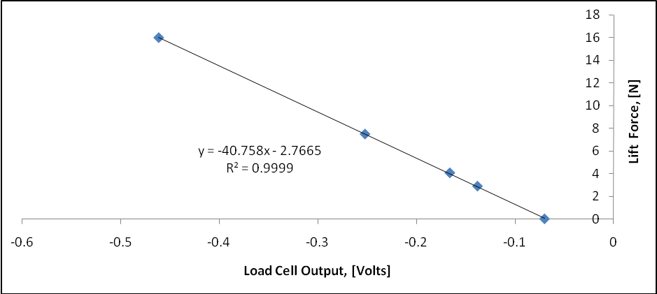
  Force [N] | Lift [V]
  0 | -0.0698
  2.892 | -0.1379
  4.068 | -0.166
  7.499 | -0.2521
  16.028 | -0.4616
Figure 6: Load cell calibration curve

- Plot Cp versus x/c for each angle of attack. Plot the benchmark data (Figure 7a) corresponding to the same angle of attack on the same graph. Show the calculated uncertainty for Cp at the tap number where precision limits was performed, using an uncertainty band. Indicate the percentage of uncertainty on the graph. Example plots are given in the data reduction spreadsheet.
- Plot the results for _{CL}, obtained from both pressure distribution and load cell, with the benchmark data. Figure 7b shows the benchmark data for _{CL}, and the coordinates are given in data reduction sheet. Also, plot the results for _{CD}, obtained from both pitot-probe and hotwire using the velocity profile measurement and load cell, with the benchmark data. Figure 7c shows the benchmark data for _{CD}, and the coordinates are given in the data reduction sheet.
- Include a plot of the normalized velocity profile measurement for each angle-of-attack using data from pitot probe and hot wire. During the step 5 of data acquisition (see section 3.1.2), a time-history of hot-wire velocity measured at a certain elevation (e.g., at -10mm from the wing trailing edge) is provided. Read carefully the pages 418 – 419 from the text book (Fundamentals of Fluid Mechanics, 7th edition, by Munson) and report the turbulence intensity value by using the provided velocity time-history and discuss its physical meaning and include a plot of the velocity fluctuation sensed by both hot wire and pitot.

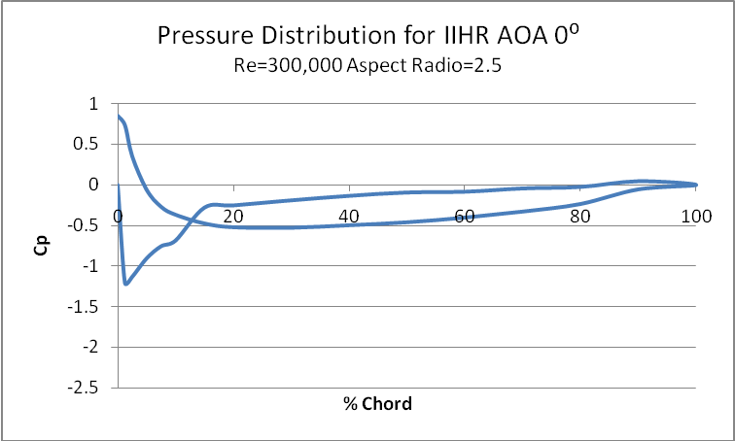 | 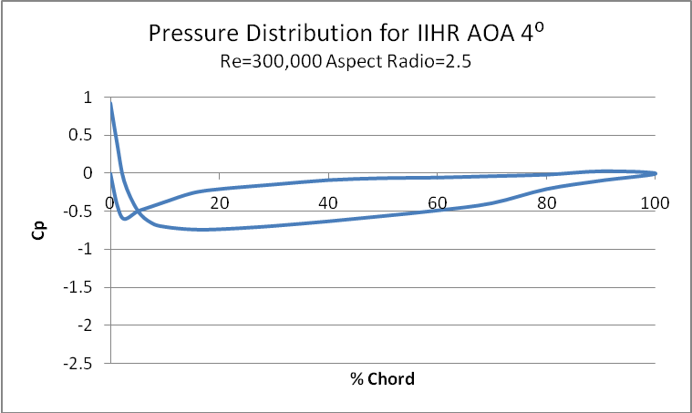
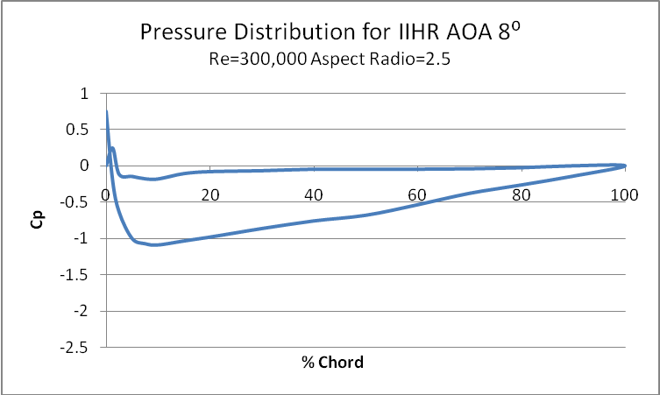 | 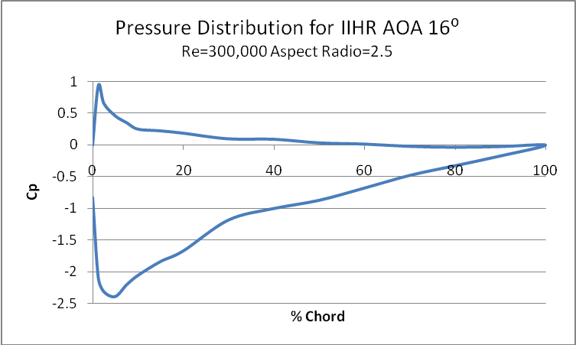
(a) Distribution of pressure coefficients for α = 0°, 4°, 8°, and 16°

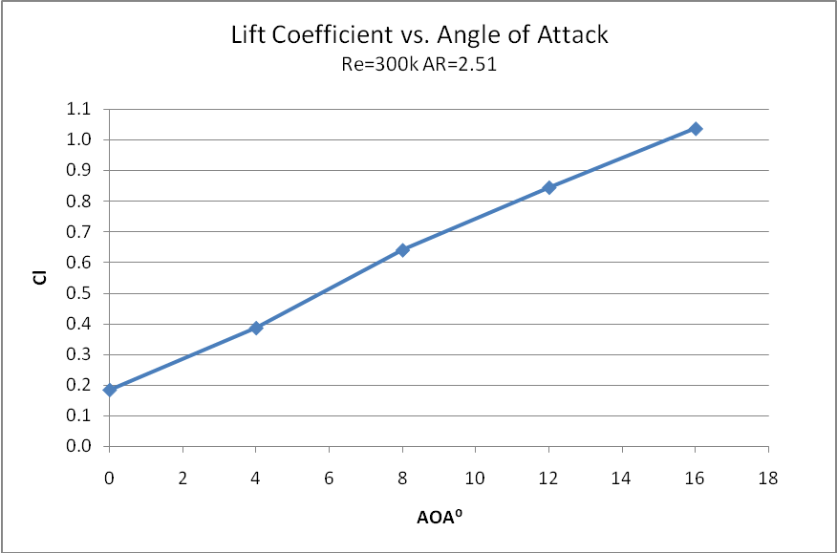 | 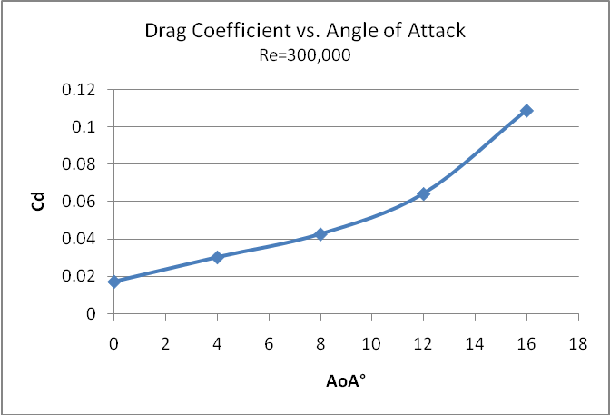
(b) Variation of C_{L} with angle of attack | (c) Variation of C_{D} with angle of attack

Figure 7: (a)-(c): Airfoil reference data at Re=300,000
4.2. Part 2: ePIV/FlowCoach
Your lab report should include the plots that you generated of the velocity vector field, streamlines around the airfoil, and velocity magnitude contours for both 0º and 16º angles of attack. Answer the following questions, and include them as well:
- Include your Reynolds number calculations for the Clark-Y airfoil model. Compare your streamline plots for each angle of attack. Do you observe any flow separation on the top surface of the airfoil? Do you expect to see any separation? Why or why not?
- On each streamline plot, mark the flow stagnation point. How should the pressure at this point compare to the pressure at other locations on the airfoil?

5. References
AIAA (1995). AIAA- 071 Standard, American Institute of Aeronautics and Astronautics, Washington, DC.
Granger, R.A. (1988). Experiments in Fluid Mechanics, Holt, Rinehart and Winston, Inc. New York, N.Y.
Marchman III, J.F. and Werme, T.D. (1984). Clark-Y Performance at Low Reynolds Numbers, Proceedings AIAA 22nd Aerospace Science Meeting, Reno, NE.
Robertson, J.A. and Crowe, C.T. (1993). Engineering Fluid Mechanics, 5th edition, Houghton Mifflin, Boston, MA.
Stern, F., Muste, M., Beninati, L-M., Eichinger, B. (1999). Summary of Experimental Uncertainty Assessment Methodology with Example, IIHR Report, Iowa Institute of Hydraulic Research, The University of Iowa, Iowa City, IA.
White, F.M. (1994). Fluid Mechanics, 3rd edition, McGraw-Hill, Inc., New York, N.Y.

APPENDIX A
SPECIFICATIONS FOR THE EXPERIMENTAL FACILITY COMPONENTS

Relevant geometrical notations are provided in Figure 3b. The positioning of the pressure taps on the airfoil surface is also specified in Figure 3b.  Airfoil Geometry:  - maximum thickness, t = 0.0254 m;  - airfoil wing span, b = 0.762 m;  - chord length, c = 0.3048 m  Angle notations:  - surface to chord line angle, β;  - angle of surface normal to  free- stream flow, θ;  - angle of attack,α.  The numerical values for the airfoil relevant geometrical characteristics are provided in the table to the right. These values are also provided in the data reduction sheet. Lift force can be computed using the trapezoidal scheme for the numerical integration  $$\begin{aligned}L=\int{\left(p_{i}−p_{∞}\right)}\text{sin}\left(θ_{i}\right)\text{ds} \\ \sum_{i}{\frac{1}{2}}\left[\left(p_{i}−p_{∞}\right)+\left(p_{i−1}−p_{∞}\right)\right]\text{sin}\left(θ_{i−1,i}\right){Δs}_{i−1,i}\end{aligned}$$
  N  Tap  Number (i) | x/C | Δs  Surface Element Length (mm) | β  Surface (i-1) - (i) to Chord Line Angle (degrees)
  0 | 0.00 | 8.0 | 209.0
  1 | 1.25 | 6.0 | 160.7  136.
  2  3 | 2.50 | 6.0 | 136.2
  3 | 5.00 | 9.0 | 115.8
  4 | 7.50 | 9.0  8.08.0  33333 | 107.3
  5 | 10.00 | 8.0 | 102.6
  6 | 15.00 | 15.5  3 | 100.1
  7 | 20.00 | 15.5 | 97.1
  8 | 30.00 | 30.0 | 93.2
  9 | 40.00 | 30.0 | 89.8
  10 | 50.00 | 30.0 | 86.7
  11 | 60.00 | 31.5 | 83.9
  12 | 70.00 | 31.5 | 81.9
  13 | 80.00 | 31.5  31 | 81.1
  14 | 90.00 | 31.5 | 79.7
  Trailing Edge | 100.00 | 30.0 | 78.6
  15 | 90.00 | 29.0 | 272.4
  16 | 80.00 | 31.0 | 272.4  272.4
  17 | 70.00 | 31.0 | 272.4
  18  18 | 60.00 | 31.0 | 272.4
  19 | 50.00 | 31.0 | 272.4
  20 | 40.00 | 30.0 | 272.4
  21 | 30.00 | 30.0 | 272.4
  22 | 20.00 | 30.0 | 272.4
  23 | 15.00 | 15.5 | 272.4
  24 | 10.00 | 15.5 | 272.4
  25 | 7.50 | 7.5 | 272.4
  26 | 5.00 | 9.0 | 265.5
  27 | 2.50 | 6.0 | 253.4
  28 | 1.25 | 4.5 | 241.0

APPENDIX B
THE AUTOMATED DATA ACQUISITION SYSTEM (ADAS)

Step 1: Calibration of Load Cell
a. Getting started with the calibration of load cell. Double click on the program Lift_Force_Xducer_Calibration.vi from the ADAS shortcut and open the calibration program. | 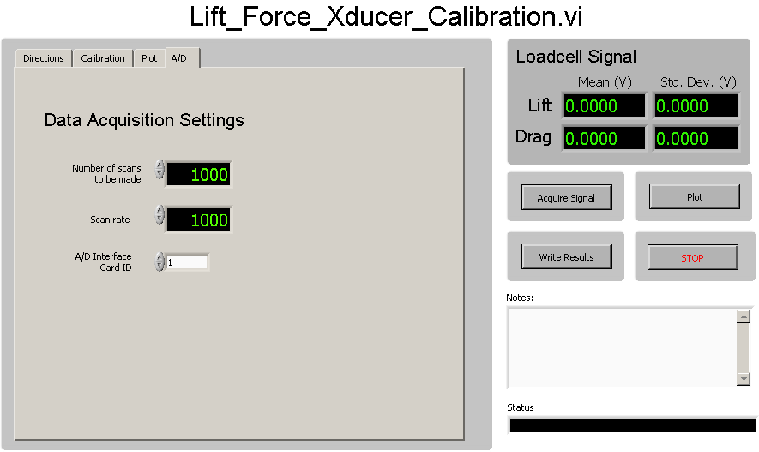
 | Figure B.1
b. From the main menu select Calibration. A table shown in the right cell will pop up showing the mass (kg) versus lift and drag forces (Volts). Hit Run to start the program and click on Acquire Signal. Keep increasing the weights on the Load cell as directed by the TA and keep acquiring data to obtain the linear regression. The data recorded can be seen on the table. | 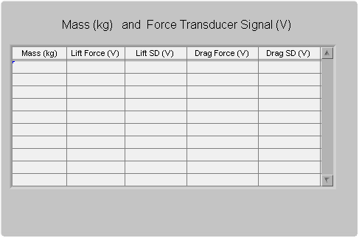
 | Figure B.2
c. Select and click on the Plot tab from the main menu. The linear calibration curve between the loading mass and the output voltage can be observed once you hit the Plot button on the Load cell Signal as shown in Figure B.3. | 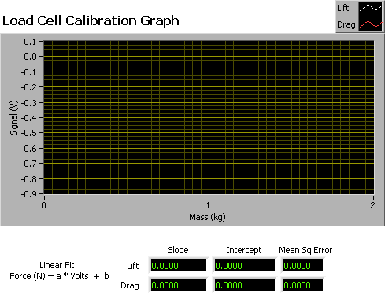
 | Figure B.3
d. Click on Write Results from the Load cell Signal box and the recorded data will be written to an output text file that will be used later to convert the signal from Volts to Newtons. | 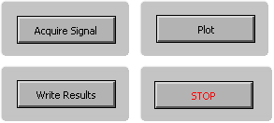
 | Figure B.4

Step 2: Setting up Wind Tunnel Conditions
a. Once the calibration is complete, the next step is to switch on the wind tunnel. The wind tunnel desired speed is controlled using the program shown in Figure B.5. Open the program VWT_Set_Motor_Speed.vi from the ADAS. Click Run button on the program. | 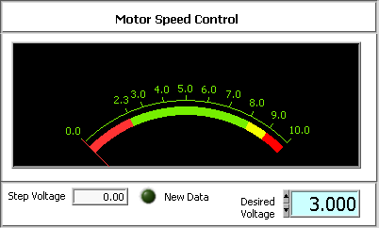
 | Figure B.5
b. Open program VWT_Tunnel_Velocity.vi and hit Run after inputting the atmospheric pressure in mm of Hg in the Ambient Pressure box. The wind tunnel velocity is displayed on the lower left hand corner of the main page.  Adjust the speed on the tunnel by adjusting the Desired Voltage as shown in Figure B.5. Once the wind tunnel velocity is set at the desired level proceed to step 3. | 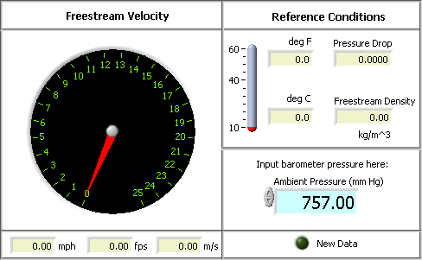
 | Figure B.6

Step 3: Measurement of pressure distribution
a. Open program VWT_Scanivalve_Data_Acquisition.vi.  Select the Ref Cond tab from the main menu. Enter the values of ambient absolute pressure in the box as shown in Figure B.7. | 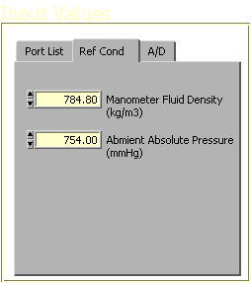
 | Figure B.7
b. After entering the density and pressure values, select Port List tab from the main menu. Enter the pressure tap numbers in the order they are required to be scanned as shown in Figure B.8. Click on the Run button to start scanning the pressure taps. | 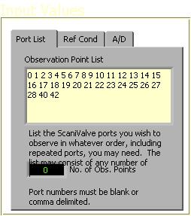
 | Figure B.8

Step 4: Lift and drag force measurement
c. Open program ATMI_Load_Cell_Test.vi and click Run. The instantaneous lift force will be displayed on the Lift graph. The display shows the force in terms of volts, which can be converted to Newtons using the calibration curve. Once the force is noted click on the STOP button. | 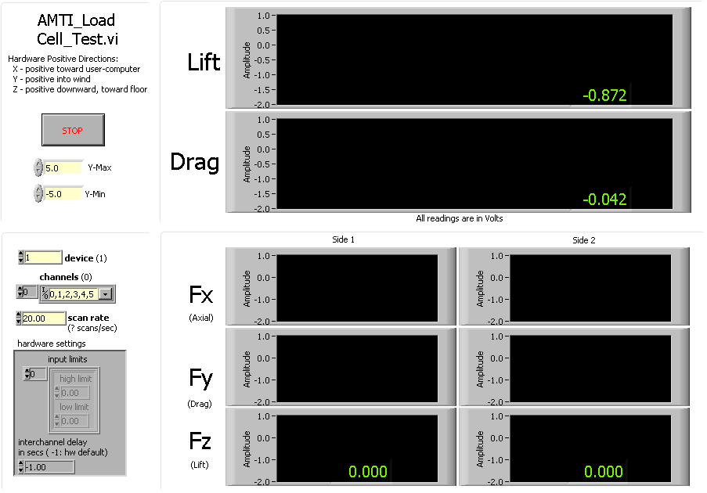
 | Figure B.9

Step 5: Measurement of velocity profile
a. Open program VWT_Wake_Survey.vi.  Select the Input tab from the main menu. Enter the values of settling time, angle of attack, and the ambient absolute pressure in the three boxes as shown in Figure B.10. Then specify the output file path and file name by clicking on the folder button as shown in Figure B.10. | 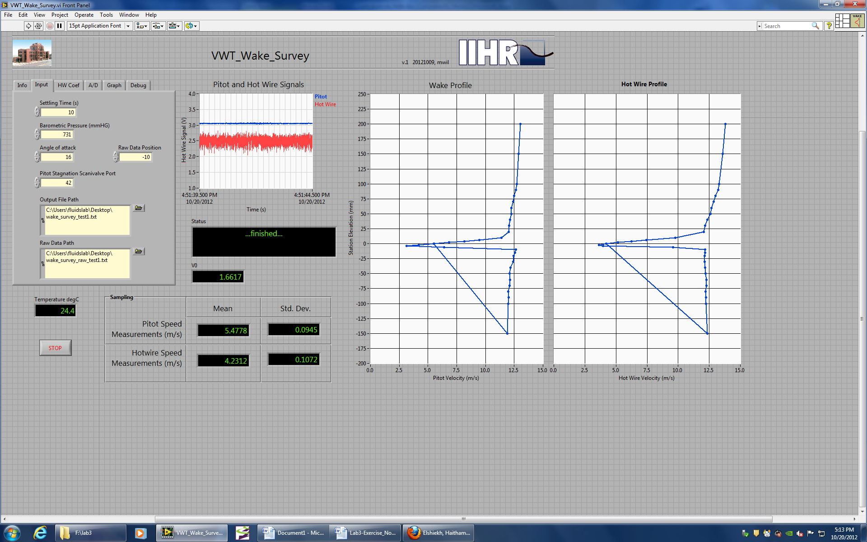
 | Figure B.10
b. Next select the A/D tab and specify the input channel the Hot-wire and pressure transducer is connected to. Specify sampling time and data rate. Refer to Figure B.11 | 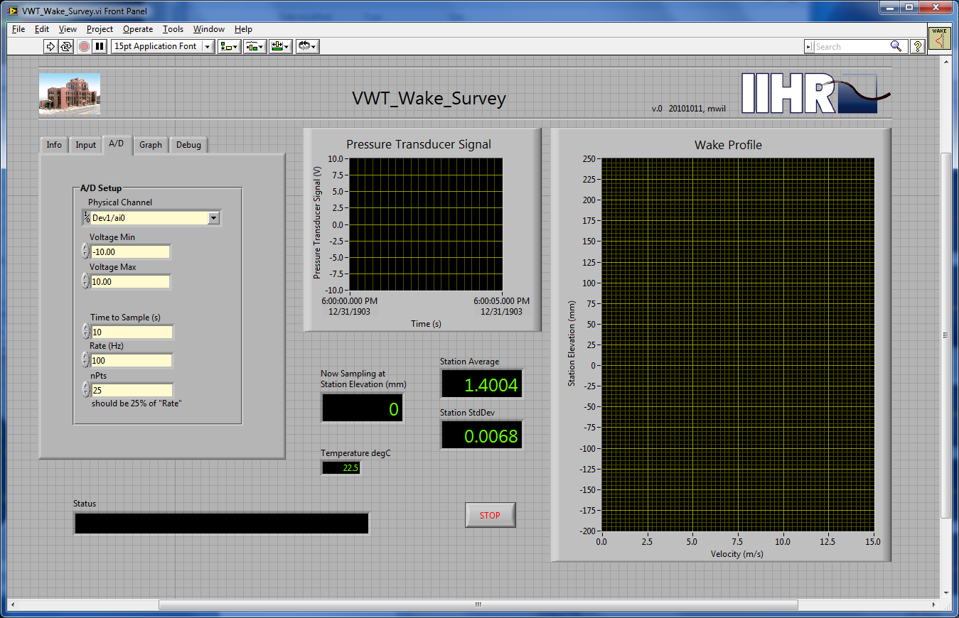
 | Figure B.11
c. Open the input file VHIL_Station_List.txt. Verify all the Pitot tube elevation positions are correct in mm. See Figure B.12. With the Fan completely turned off, open the VWT_Set_Motor_Speed.vi shown in step 2 and set the fan voltage to the desired speed (15 m/s). Click Run and File-save, then close this VI | 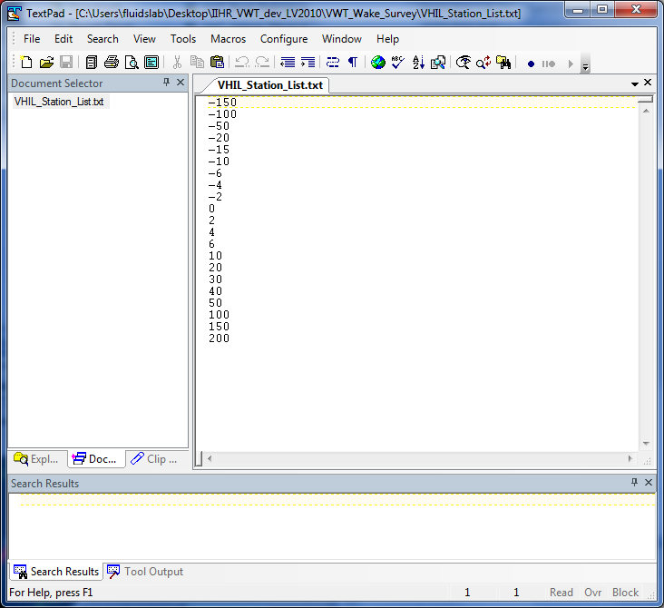
 | Figure B.12
d. Ensure the Hot-wire and Pitot tube datum has been established by first locating the tip of the traverse-mounted Hot-wire and Pitot tube at the elevation of the airfoil trailing edge. Click Run to take a record of the Hot-wire zero volt and when promoted, turn the tunnel fan on and click OK and the DA will move the Hot-wire and Pitot tube to the specified elevations to record velocity. The velocity profile will be displayed in the plot. See Figure B.13. | 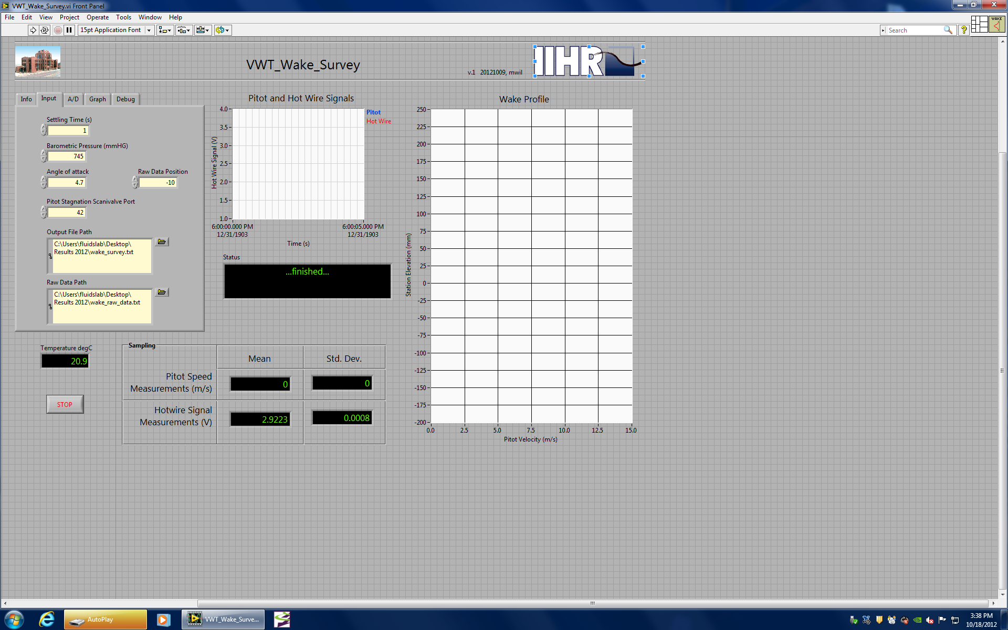
 | Figure B.13

